**THINGS TO LEARN STEP BY STEP**

**DAY 1:**

Open cv image read, show, write

Open google colab first and open new notebook

Import libraries

Code:

from google.colab import files

import cv2

import matplotlib.pyplot as plt

exp:

line 1: files is imported to upload files to google colab

line 2: cv2 is imported which is computer vison or called as open cv

line 3: import matplotlib.pyplot to plot the image

upload file to google colab

code:

uploaded = files.upload()

exp:

line 1: after running this command select the file to upload

output:

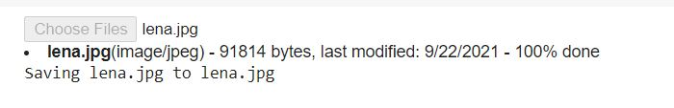

Read image and convert to RGB and show image

Code:

img =cv2.imread("lena.jpg")

img=cv2.cvtColor(img,cv2.COLOR\_BGR2RGB)

plt.imshow(img)

exp:

line 1: imread function is used to read image and inside double quates name of image to read is used.

Line 2: the image is read in BGR format (blue green red) and it is converted to RGB format (red blue green) by using cvtcolor function.

Line 3: imshow image is used to show image and plot is used to plot the image.

Output:

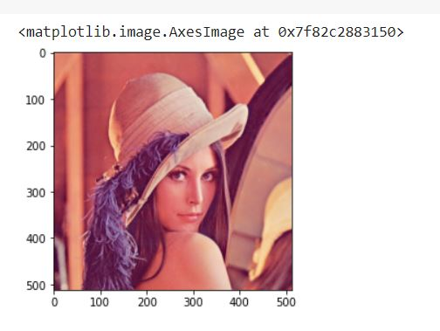

Aliter to display uploaded image

Code:

import matplotlib.image as mpimg

img = mpimg.imread("lena.jpg")

plt.imshow(img)

exp:

line 1: the previous method for showing image can also be done by importing image library from matplotlib and it will directly load image in RGB format so it can be displayed directly without coversion.

Line 2,3 previously explained

Output:

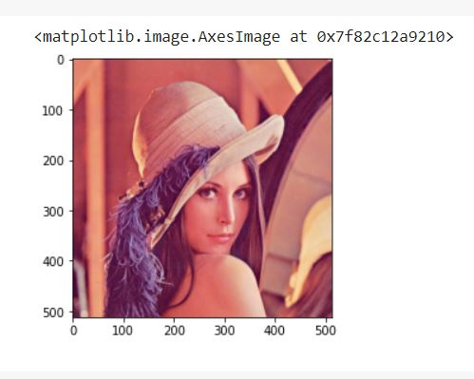

Aliter to read image

Code:

import numpy as np

import cv2

img=cv2.imread("/content/lena.jpg")

exp:

line 1: imported numpy library

line 2: imported open cv [line 2 is not mandatory hence it is already imported]

line3: reading image, location of uploaded file is given double quotes.

Aliter to show image

Code:

from google.colab.patches import cv2\_imshow

cv2\_imshow(img)

exp:

line 1: imshow function is imported

line 2: variable name of image to show is given inside closed bracket.

Output:

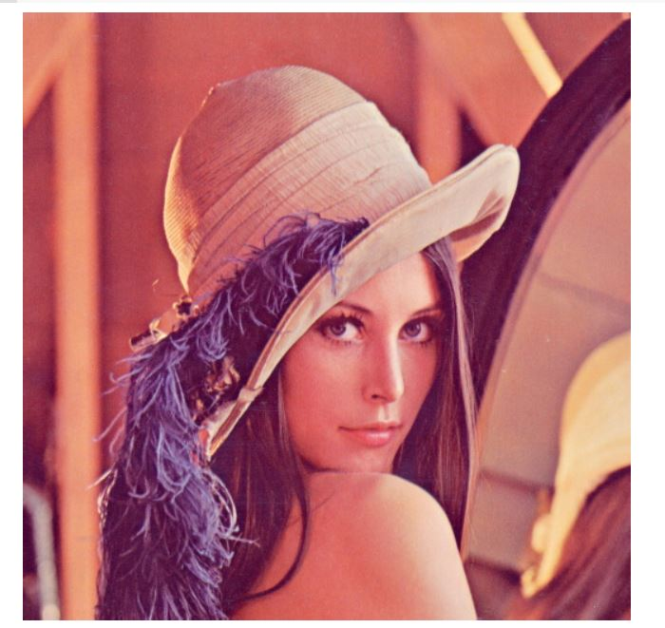

Colour change of image

Code:

img\_color=cv2.imread("/content/lena.jpg",1)

img\_grayscale=cv2.imread("/content/lena.jpg",0)

img\_unchanged=cv2.imread("/content/lena.jpg",-1)

exp:

|  |  |  |
| --- | --- | --- |
| Type of image to read | Flag value | Description |
| Colour image | 1 | Loads image with colour colour image |
| Grayscale image | 0 | Loads image with grayscale image |
| Unchanged image | -1 | Loads actual image with alpha value |

Displaying colour changed loaded images

Code:

cv2\_imshow(img\_color)

cv2\_imshow(img\_grayscale)

cv2\_imshow(img\_unchanged)

exp: previously explained.

Output:

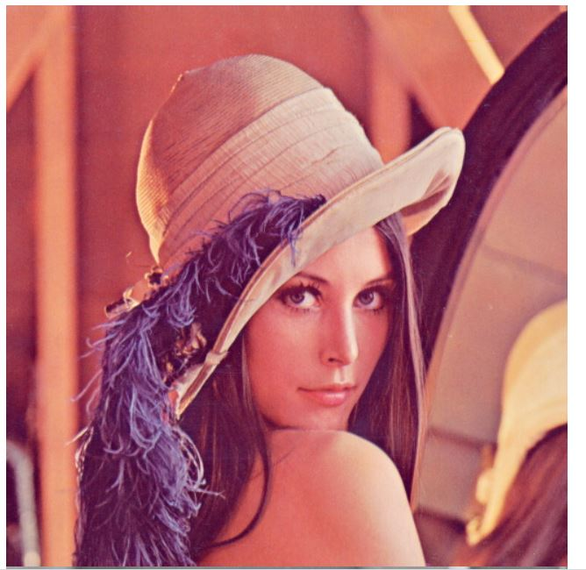

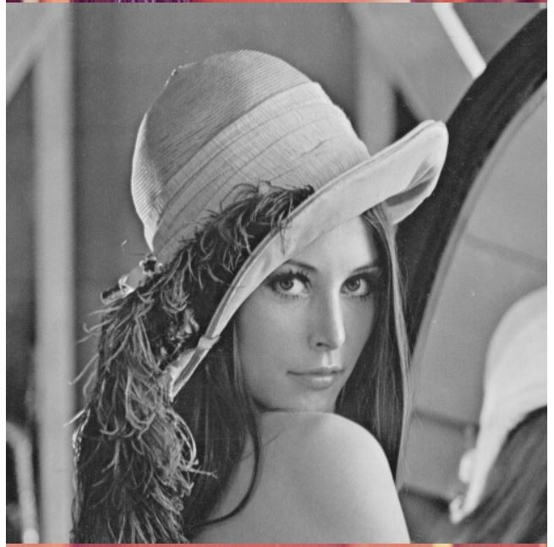

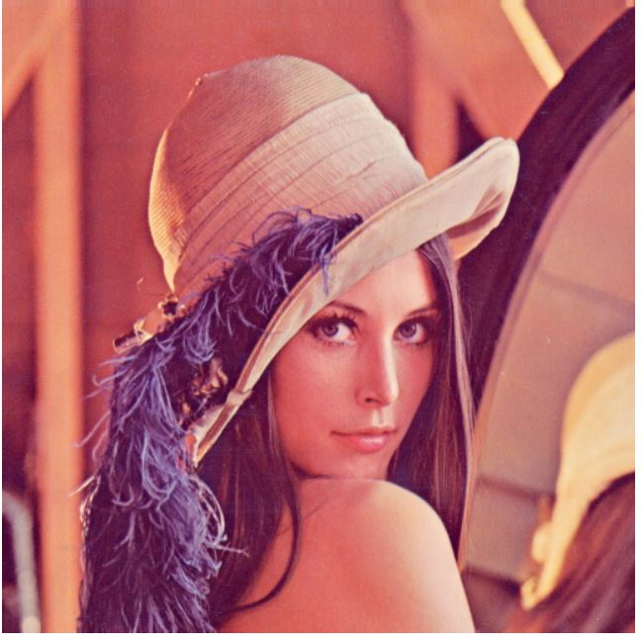

Write or save image

Code:

cv2.imwrite("saved\_img.png",img\_grayscale)

exp:

imwrite function is used to save or write a new image. The will be saved with name and format given inside the double or single quotes.

Output:

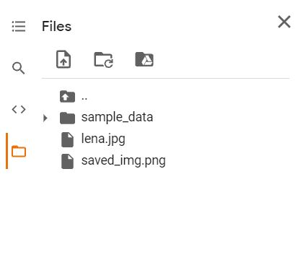

To find pixels and shape and size of image

Code:

img=plt.imread("lena.jpg")

print(img.shape)

print("The image consists of %i pixels" % (img.shape[0] \* img.shape[1]))

plt.imshow(img);

exp:

line 1: read the image

line 2: print the shape of the image which gives size of the image.

line 3: print the pixels of the image [0] for height of image and [1] for width of image.

line 4: show the image.

Output:

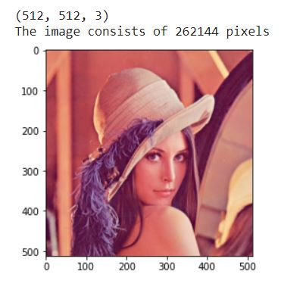

Mirror the image or invert in X direction

Code :

plt.imshow(img[:,::-1]);

exp:

image is shown using plt command and inverted in X direction

Output:

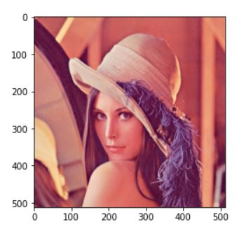

Inverting the image without damaging the actual image

Code:

img2=img.copy()

img2[0:30, :, :]=1.0

plt.imshow(img2)

exp:

line 1: copying the img 1 to img 2

line 2: inverting the image in X direction. (since the image is already inverted so it will be looks like original after inverting)

line 3: show the image.

Output:

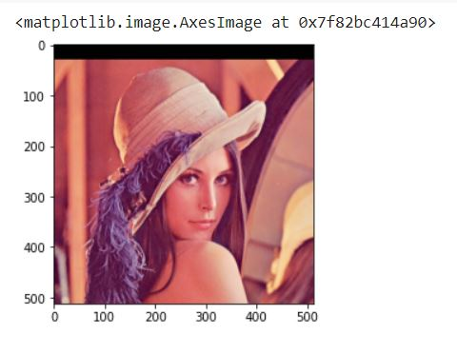

Importing images using url

Code:

from skimage import io

exp:

import io from skimage library to get image inputs

code:

urls=["https://iiif.lib.ncsu.edu/iiif/0052574/full/800,/0/default.jpg",

      "https://iiif.lib.ncsu.edu/iiif/0016007/full/800,/0/default.jpg",

      "https://placekitten.com/800/571"]

for url in urls:

  image = io.imread(url)

  image\_2 = cv2.cvtColor(image, cv2.COLOR\_BGR2RGB)

  final\_frame = cv2.hconcat((image, image\_2))

  cv2\_imshow(final\_frame)

  print('\n')

exp:

line 1-3: url of image 1to image 3 in a list named urls.

Line4: for loop to read and show all the image url present in urls list.

Line5: read image inside for loop

Line6: converting the image from BGR format to RGB format. Since in default it reads in BGR format. Thus, BGR format stored in image 1 and RGB format is stored in image2.

Line7: cv2.hconcat is a function to join image1 and image2 and it is assigned in final frame.

Line8: show final frame so both BGR and RGB images are shown.

Line9: print new line to ensure space between above and below images.

#### To Read an image from a URL and display it

Image source examples:

[Place Kitten](https://placekitten.com/) - use the base Place Kitten URL followed by a width and height separated by backslashes ''/''. For example, use the URL https://placekitten.com/500/300 to fetch a cat image with a width of 500px and height of 300px.

[NC State University Libraries Special Collections](https://d.lib.ncsu.edu/collections/catalog) - browse the site to find an image thumbnail. Right-click on the thumbnail and select "Copy Image Address". The address will look like this: https://iiif.lib.ncsu.edu/iiif/0051230/square/300,/0/default.jpg. Replace the word "square" with the word "full" and replace "300" with "800" to access the full image at a width of 800px.

[Google Image search](https://www.google.com/imghp?hl=en) - search for an image. Left-click one of the returned images, then right-click on the full image, and then select "Copy Image Address".

Output:

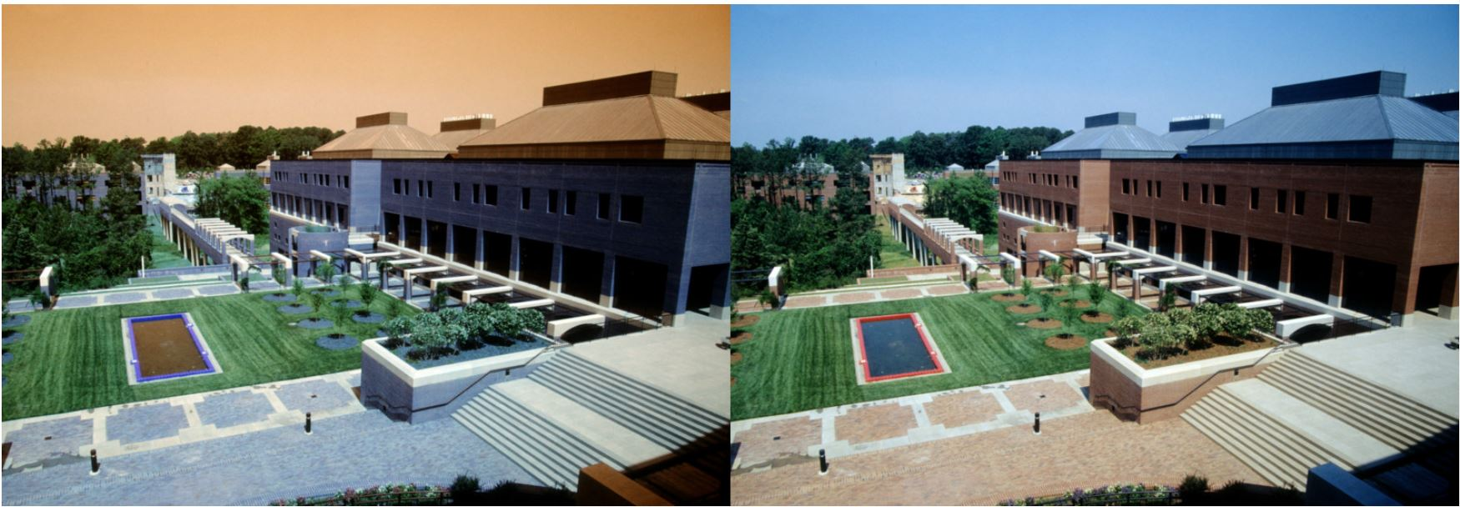

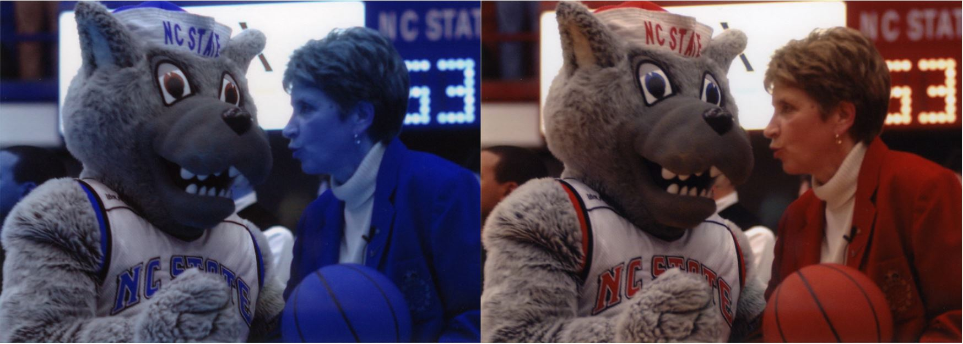

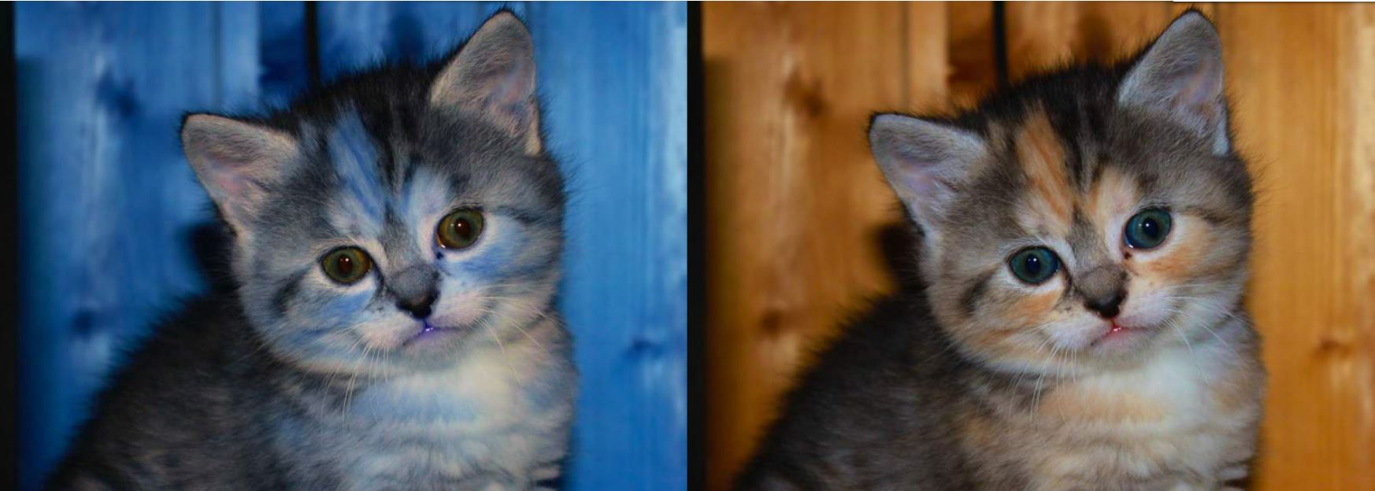

Image counters and histogram

Code:

print(image.dtype)

print(image.shape[0])

print(image.shape[1])

print(image.shape[2])

exp:

line1: checks the data of the image and prints it.

Line2: checks the height of the image and prints it.

Line3: checks the width of the image and prints it.

Line4: checks the number of channels of the image

Output:

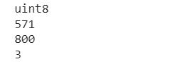

Generate histogram of the colour image

Code:

plt.hist(image.ravel(),bins = 256, range = [0,256])

plt.show()

exp:

line1: plot the histogram from range 0 to 256

line2: show the histogram

Output:

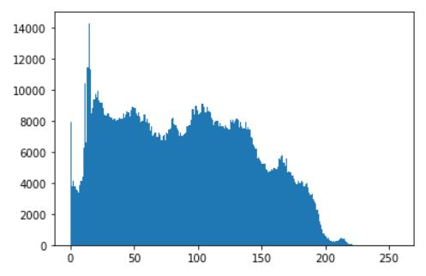

To display the RGB colour pixels in histogram

Code:

color = ('b','g','r')

for i,col in enumerate(color):

    histr = cv2.calcHist([image],[i],None,[256],[0,256])

    plt.plot(histr,color = col)

    plt.xlim([0,256])

plt.show()

exp:

line1: r,g,b in function of colurs

line2: for loop to run rgb in set and form histogram repetitively for r,g,b.

line3: form histogram with the rgb pixel colours.

In the bracket of histogram

[image]- your image

[i]-  channel color of histogram chose [0] if your image is in gray scale. in case of color image [0] is for blue, [1] for green and [2] for red.

None -  this is for select point of the picture that you want to calculate. none is for full frame. If you want to choose the frame, you need to made it before.

[256] - this is for “bin” or we can call “brackets”. Anywhere for full of gray scale we use 256.

[0,256] – this is the range of pixel values.

Line4: plot the histogram.

Line5: show the histogram

Output:

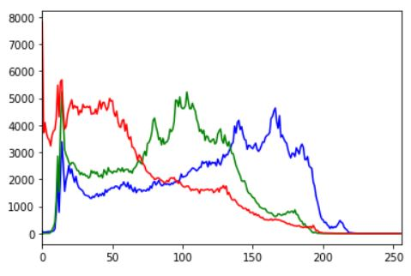

Aliter to colour change of image

Code:

gray\_image = cv2.cvtColor(image, cv2.COLOR\_BGR2GRAY)

cv2\_imshow(gray\_image)

exp:

line1: converting RGB image to grayscale using cvtcolor function.

line2: show the image.

Output:

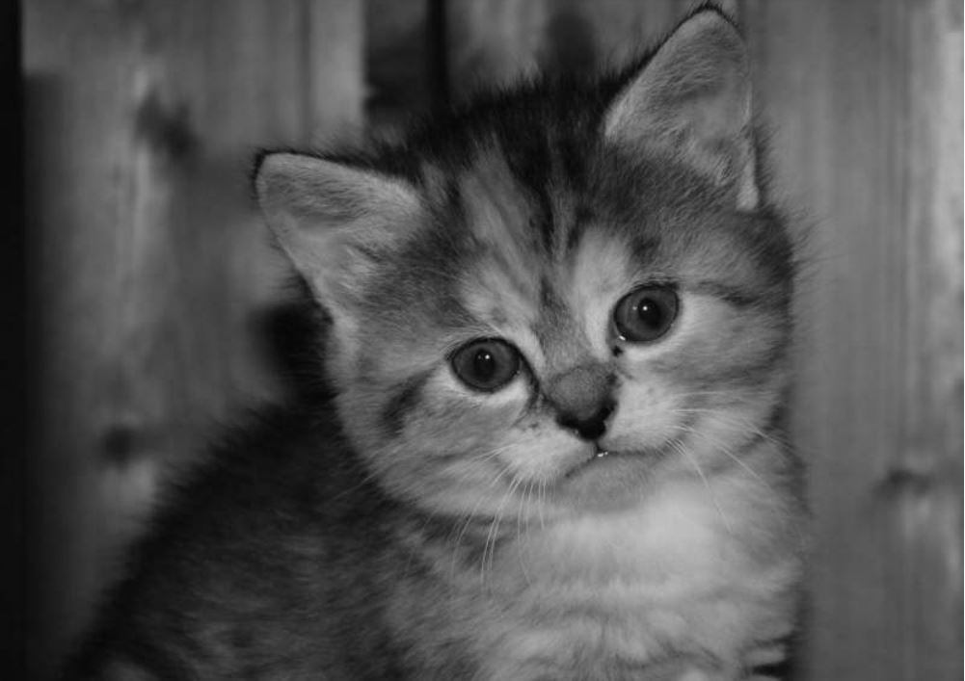

Plot greyscale image in histogram

Code:

plt.hist(gray\_image.ravel(),bins = 256, range = [0, 256])

plt.show()

exp:

line1: plot the greyscale image in the histogram

line2: show the histogram.

Output:

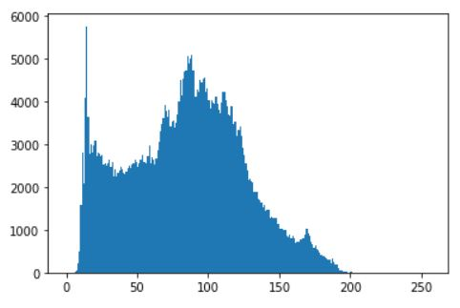

Edge detection in image matplotlib.contour

Code:

plt.contour(gray\_image, origin = "image")

exp:

contour is the function used to detect the edge of the image and make sure it is in grayscale for better result.

Output:

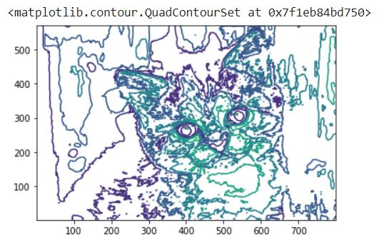

Edge detection of image using contours in opencv using library

Code:

ret, thresh = cv2.threshold(gray\_image,150,255,0)

contours, hierarchy = cv2.findContours(thresh, cv2.RETR\_TREE, cv2.CHAIN\_APPROX\_SIMPLE)

cv2.drawContours(image, contours, -1, (0, 255, 0), 3)

plt.imshow(image)

exp:

line1: setting threshold value for the grayscale image

line2: finding contours and hierarchy

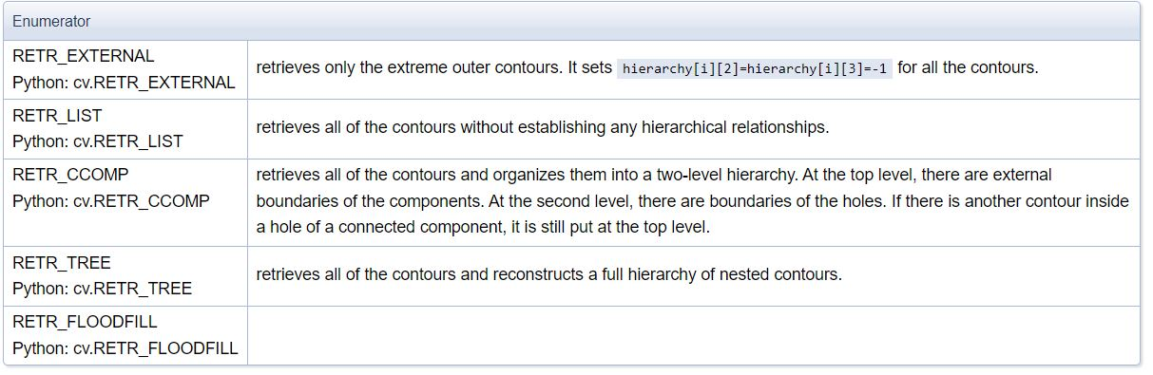

Line3: using drawcontour function to draw lines on edges of the image.

Line4: show the image.

Output:

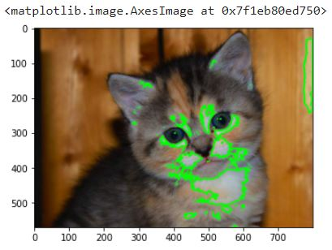

Grayscale transform

Code:

im2 = 255 - gray\_image

cv2\_imshow(im2)

exp:

This is the inverse operation of grayscale where light pixel becomes dark and dark pixels becomes bright.

Output:

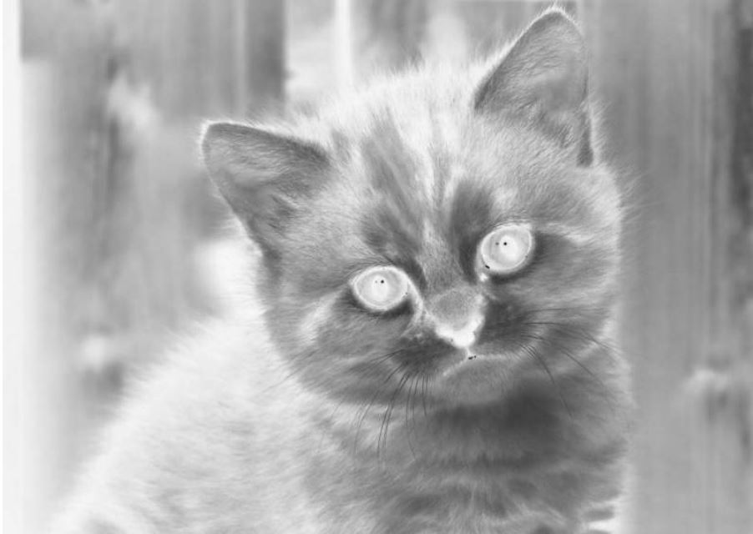

Make grayscale image little brighter by adding constant

Code:

im3 = (100.0/255)\*gray\_image + 100

cv2\_imshow(im3)

exp:

By adding constant to the image, the pixels become brighter and hazing like image is generated.

Output:

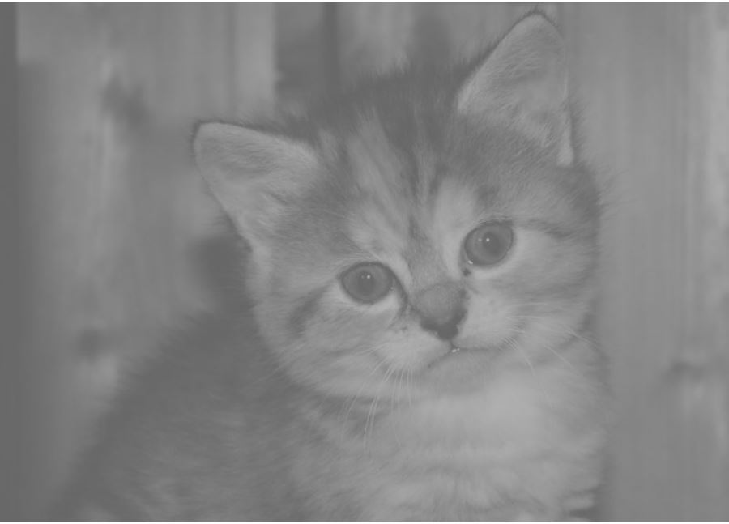

Reduce the lightness level of grayscale image

Code:

im4 = 255.0\*(gray\_image/255.0)\*\*2

cv2\_imshow(im4)

exp:

The lightness level of the image is reduced by dividing and multiplying constants.

Output:

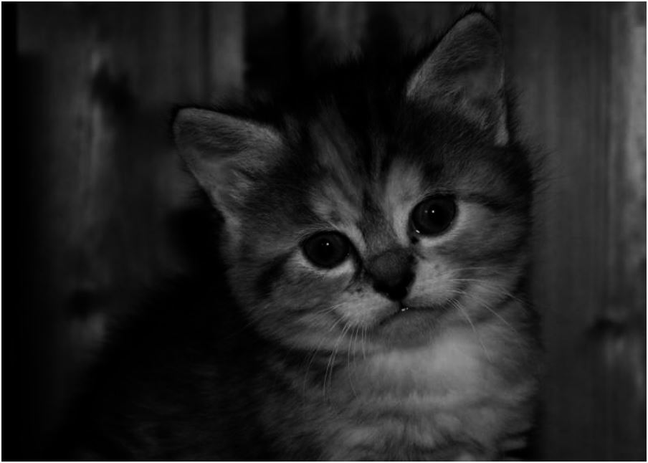

Histogram equalization

Code:

def histeq(im, nbr\_bins = 256):

  imhist, bins = np.histogram(im.flatten(), nbr\_bins, [0, 256])

  cdf = imhist.cumsum() # cumulative distribution function

  cdf = imhist.max()\*cdf/cdf.max()  #normalize

  cdf\_mask = np.ma.masked\_equal(cdf, 0)

  cdf\_mask = (cdf\_mask - cdf\_mask.min())\*255/(cdf\_mask.max()-cdf\_mask.min())

  cdf = np.ma.filled(cdf\_mask,0).astype('uint8')

  return cdf[im.astype('uint8')]

im5 = histeq(im4)

cv2\_imshow(im5)

exp:

This section demonstrates histogram equalization on a dark image. This transform flattens the gray-level histogram so that all intensities are as equally common as possible. The transform function is a cumulative distribution function (cdf) of the pixel values in the image (normalized to map the range of pixel values to the desired range)

line1: defining the function of histogram

line2: get the image histogram

line3: the cumulative distributive function is assigned

line4: normalizing with cumulative distributive function

line5: used equals to filtration process

line6: cdf mask calculation

line7: assigning cdf with filled pixel

line8: returning the cdf

line9: passing the image for histeg function

line10: show the image.

Output:

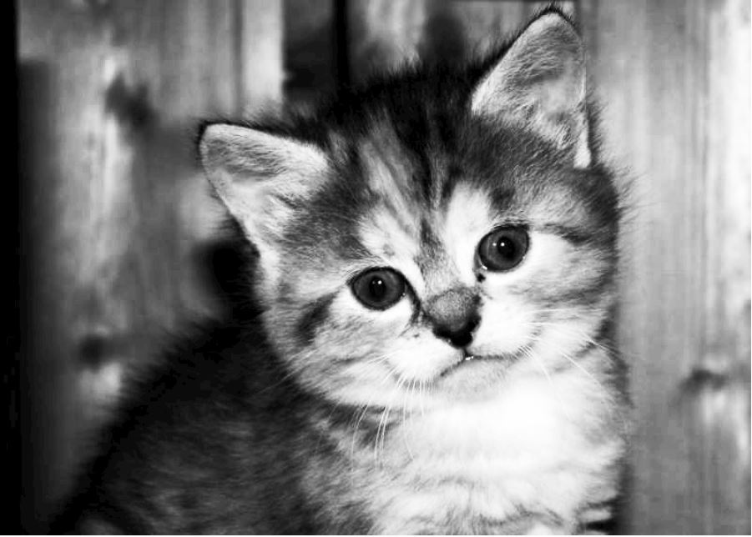

Before histogram equalization

Code:

plt.hist(im4.ravel(),bins = 256, range = [0, 256])

plt.show()

exp:

histogram for image 4 is plotted which is non equalized image.

Output:

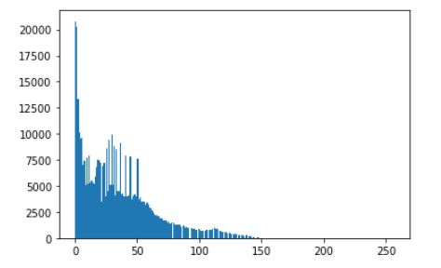

After histogram equalization

Code:

plt.hist(im5.ravel(),bins = 256, range = [0, 256])

plt.show()

exp:

The histogram is plotted for image 5 which is after equilization.

Output:

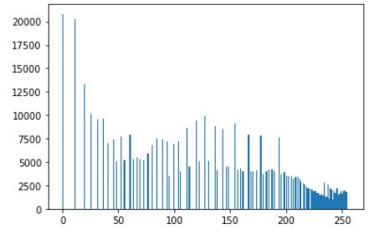

Fourier transform of Gray image

Code:

# Blur the grayscale image by a Guassian filter with kernel size of 10

imBlur = cv2.blur(gray\_image,(5,5))

# Transform the image to frequency domain

f = np.fft.fft2(imBlur)

# Bring the zero-frequency component to the center

fshift = np.fft.fftshift(f)

magnitude\_spectrum = 30\*np.log(np.abs(fshift))

plt.subplot(121),plt.imshow(imBlur, cmap = 'gray')

plt.title('Input Image'), plt.xticks([]), plt.yticks([])

plt.subplot(122),plt.imshow(magnitude\_spectrum, cmap = 'gray')

plt.title('Magnitude Spectrum'), plt.xticks([]), plt.yticks([])

plt.show()

exp:

A fourier transform is used to find the frequency domian of an image. You can consider an image as a signal which is sampled in two directions. So taking a fourier transform in both X and Y directions gives you the frequency representation of image. For the sinusoidal signal, if the amplitude varies so fast in short time, you can say it is a high frequency signal. If it varies slowly, it is a low frequency signal. Edges and noises are high frequency contents in an image because they change drastically in images.

Line 1: blur the gary image using blur function with gaussian filter.

Line 2: transform the image to frequency domain using transform function.

Line 3: center all the zero frequency components to the center of the image.

Line 4: The magnitude range of the frequencies are assigned to magnitude spectrum.

Line 5: using subplot to plot the image

Line 6: get the location of pixels of image in x and y and plot it.

Line 7: plot the magnitude of image using subplot

Line 8: get the locations of magnitudes in x and y and plot it.

Line 9: show the plot.

Output:

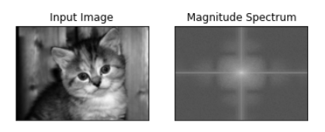

Find the edges by highpass filtering in FFT

Code:

rows, cols = imBlur.shape

crow,ccol = round(rows/2) , round(cols/2)

# remove low frequencies with a rectangle size of 10

fshift[crow-10:crow+10, ccol-10:ccol+10] = 0

f\_ishift = np.fft.ifftshift(fshift)

img\_back = np.fft.ifft2(f\_ishift)

img\_back = np.abs(img\_back)

plt.figure(figsize=([20, 20]))

plt.subplot(131),plt.imshow(imBlur, cmap = 'gray')

plt.title('Input Image'), plt.xticks([]), plt.yticks([])

plt.subplot(132),plt.imshow(img\_back, cmap = 'gray')

plt.title('Image after HPF'), plt.xticks([]), plt.yticks([])

plt.subplot(133),plt.imshow(img\_back)

plt.title('Result in JET'), plt.xticks([]), plt.yticks([])

plt.show()

exp:

line 1: pixels of image or size of image is stored in row and column

line 2: rounding off the row and column

line3: removing the low frequencies

line 4: using FFT function to get frequency transform.

Line 5: using FFT function to get frequency transform.

Line 6: getting the absolute of frequency transform matrix

Line 7: plot the figure size.

Line 8: using subplot to plot the image

Line 9: getting the locations of pixels in input image in both x and y directions.

Same process is carried out for rest for remaining image with HPF and JET.

Output:

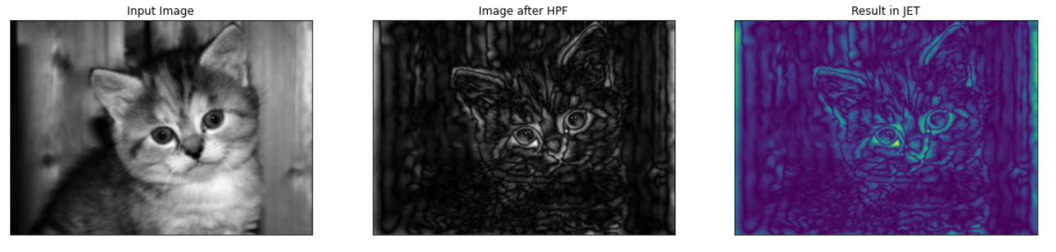

creating random clusters in image

Code:

n=5

l=256

im = np.zeros((l,l))

np.random.seed(0)

points = np.random.randint(0, l, (2, n\*\*2))

im[points[0], points[1]] = 1

plt.imshow(im);

exp:

line 1,2: declaration and assigning values to variables.

Line 3: creating array of zeros

Line 4,5: creating an array of random numbers

Line 5: show the points as image

Output:

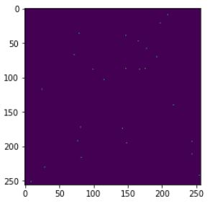

Enhancing and filtering random cluster

Code:

from scipy import ndimage

im2 = ndimage.gaussian\_filter(im, sigma=l/(8.\*n))

plt.imshow(im2);

exp:

line 1: importing the library

line2: using gaussian filter function to blur and enhance the image

line 3: show the image.

Output:

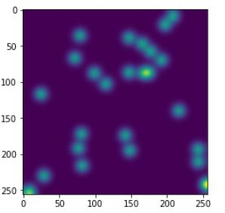

Finding cluster in the image

Code:

mask = im2 > im2.mean()     # mask those pixels whose intensity is above mean

label\_im, nb\_labels = ndimage.label(mask)   # connected components form clusters

print("Number of clusters is %i" % nb\_labels)

plt.imshow(label\_im);

exp:

line 1: making the pixels whose intensity is above mean in the image.

Line 2: connecting the components from the cluster but considering the nonzero values as features and zeros as background.

Line 3: print the number of clusters.

Line 4: show the image.

Output:

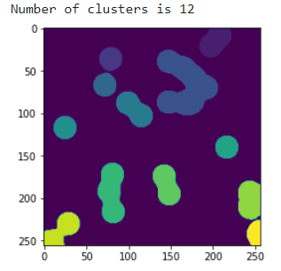

To load more images from drive easier

Code:

from google.colab import drive

drive.mount('/content/drive');

exp:

line 1: import the drive library

line 2: mount the drive library to google colab.

Output:

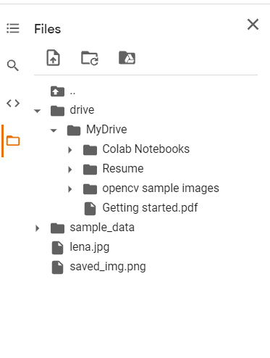

Image reading and conversion using libraries

Code:

import torch

!pip install kornia

import kornia

import torchvision

img\_bgr: np.array = cv2.imread('lena.jpg', cv2.IMREAD\_COLOR)

img\_rgb: np.array = cv2.cvtColor(img\_bgr, cv2.COLOR\_BGR2RGB)

plt.imshow(img\_rgb,); plt.axis('off');

exp:

line 1: importing torch library

line 2: installing the kornia library

line3,4: importing library

line 5: reading the image

line 6: converting the BGR format to RGB format

line 7: show the image without plot.

output:

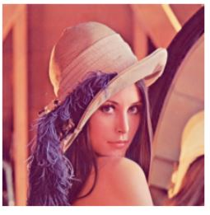

Colour conversion of images using different libraries

Code:

x\_bgr: torch.Tensor = kornia.image\_to\_tensor(img\_bgr)

plt.imshow(img\_bgr); plt.axis('off');

exp:

line 1: converting numpy array to torch

line 2: display the image without plot.

Output:

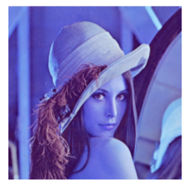

Code:

x\_rgb: torch.Tensor = kornia.bgr\_to\_rgb(x\_bgr)

# convert back to numpy and visualize

img\_np: np.array = kornia.tensor\_to\_image(x\_rgb)

plt.imshow(img\_rgb); plt.axis('off');

exp:

line 1: using kornia to convert bgr to rgb format.

Line 2: convert back to numpy

Line 3: display the image without plot.

Output:

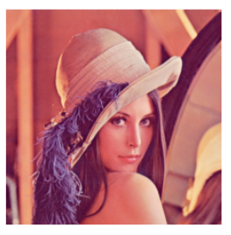

Video processing in google colab

Code:

import cv2

# Create a video capture object, in this case we are reading the video from a file

vid\_capture = cv2.VideoCapture('/content/video.mkv')

if (vid\_capture.isOpened() == False):

  print("Error opening the video file")

# Read fps and frame count

else:

  # Get frame rate information

  # You can replace 5 with CAP\_PROP\_FPS as well, they are enumerations

  fps = vid\_capture.get(5)

  print('Frames per second : ', fps,'FPS')

  # Get frame count

  # You can replace 7 with CAP\_PROP\_FRAME\_COUNT as well, they are enumerations

  frame\_count = vid\_capture.get(7)

  print('Frame count : ', frame\_count)

while(vid\_capture.isOpened()):

  # vid\_capture.read() methods returns a tuple, first element is a bool

  # and the second is frame

  ret, frame = vid\_capture.read()

  if ret == True:

    cv2\_imshow(frame)

    # 20 is in milliseconds, try to increase the value, say 50 and observe

    key = cv2.waitKey(20)

    if key == ord('q'):

      break

  else:

    break

# Release the video capture object

vid\_capture.release()

\*\*\*\*\*\*\*\*(from this page to ---- page refer the site given below for more information

<https://learnopencv.com/getting-started-with-opencv/> )\*\*\*\*\*\*\*\*\*

exp:

line 1: import library.

Line2: use video capture function to capture the video.

Line 3: check for is video is opening

Line 4: if it is not opening print that having error in opening the video.

Line 5: else run rest of the code.

Line 6: use get function to get the fps (frames per second) of the video.

Line 7: print the frames per second.

Line 8: again, use get function to get total number of frames in the video.

Line 9: print the total number of frames in the video.

Line 10: open a while function to check is video is opened or not and run loop until the end of the video.

Line 11: use video capture read function to read video frame by frame and store in two variables ret and frame. Ret value is going to be sure true if there is frame in next. So, it can be used to check whether there is a frame in next or not.

Line 12: check for the ret value using if condition.

Line 13: if it is true then use show function to display the frame it captured.

Line 14 – 17: can be avoided if you are using google colab. these lines are to stop the code using terminal when you are using IDE software. In google colab you just click again the play in the top left corner of the shell to stop the code.

Line 15: use break command to get out of the loop.

Line 16: release the video capture.

Output:

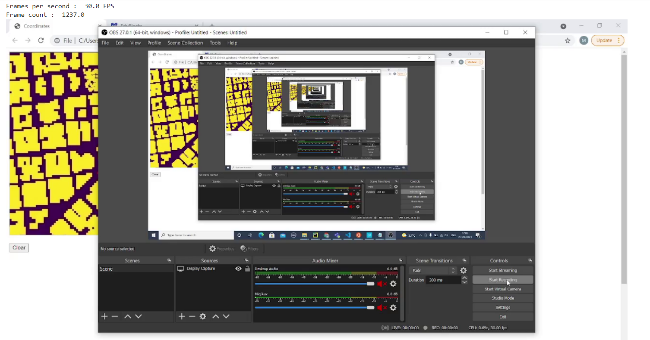

As there are 1237 frames in the video unable to display it here only have shown the first frame of the video.

Reading the image sequence:

Code:

vid\_capture = cv2.VideoCapture('Resources/Image\_sequence/Cars%04d.jpg')

replace this line with line 2 in pervious code.

Exp:

Processing image frames from an image sequence is very similar to processing frames from a video stream. Just specify the image files which are being read.

In the example below,

* You continue using a video-capture object
* But instead of specifying a video file, you simply specify an image sequence
  + Using the notation shown below (Cars%04d.jpg), where %04d indicates a four-digit sequence-naming convention (e.g. Cars0001.jpg, Cars0002.jpg, Cars0003.jpg, etc).
  + If you had specified “Race\_Cars\_%02d.jpg” then you would be looking for files of the form:

(Race\_Cars\_01.jpg, Race\_Cars\_02.jpg, Race\_Cars\_03.jpg, etc…).

All other codes described in the first example would be the same.

Output:

Similar to the output given for previous program.

Reading video from a webcam:

Code:

vid\_capture = cv2.VideoCapture(0, cv2.CAP\_DSHOW)

replace this line with line 2 in the above given program.

Exp:

Reading a video stream from a web camera is also very similar to the examples discussed above. How’s that possible? It’s all thanks to the flexibility of the video capture class in OpenCV, which has several overloaded functions for convenience that accept different input arguments. Rather than specifying a source location for a video file or an image sequence, you simply need to give a video capture device index, as shown above.

* If your system has a built-in webcam, then the device index for the camera will be ‘0’.
* If you have more than one camera connected to your system, then the device index associated with each additional camera is incremented (e.g. 1, 2, etc).

Output:

As similar to the output given above.

Writing video:

Code:

\*\*\*\*\*(previous code line 1 to line 9)\*\*\*\*\*\*

# Obtain frame size information using get() method

frame\_width = int(vid\_capture.get(3))

frame\_height = int(vid\_capture.get(4))

frame\_size = (frame\_width,frame\_height)

fps = 20

output = cv2.VideoWriter('Resources/output\_video\_from\_file.avi',

cv2.VideoWriter\_fourcc('M','J','P','G'), 20, frame\_size)

while(vid\_capture.isOpened()):

 # vid\_capture.read() methods returns a tuple, first element is a bool

# and the second is frame

ret, frame = vid\_capture.read()

if ret == True:

  # Write the frame to the output files

  output.write(frame)

else:

  print(‘Stream disconnected’)

  break

exp:

Let’s now take a look at how to write videos. Just like video reading, we can write videos originating from any source (a video file, an image sequence, or a webcam). To write a video file:

* Retrieve the image frame height and width, using the get() method.
* Initialize a video capture object (as discussed in the previous sections), to read the video stream into memory, using any of the sources previously described.
* Create a video writer object.
* Use the video writer object to save the video stream to disk.

Continuing with our running example, let’s start by using the get() method to obtain the video frame width and height.

As previously discussed, the get() method from the VideoCapture() class requires:

* A single argument from an enumerated list that allows you to retrieve a variety of metadata associated with the video frames.

The metadata available is extensive, and

* In this case, you are retrieving the frame width and height, by specifying 3 (CAP\_PROP\_FRAME\_WIDTH) and 4 (CAP\_PROP\_FRAME\_HEIGHT). You will use these dimensions further below, when writing the video file to disk.

In order to write a video file, you need to first create a video-writer object from the VideoWriter() class, as shown in the code below.

Here’s the syntax for VideoWriter():

VideoWriter(filename, apiPreference, fourcc, fps, frameSize[, isColor])

The VideoWriter() class takes the following arguments:

* filename: pathname for the output video file
* apiPreference:  API backends identifier
* fourcc: 4-character code of codec, used to compress the frames ([fourcc](https://docs.opencv.org/4.5.2/dd/d9e/classcv_1_1VideoWriter.html" \l "ad59c61d8881ba2b2da22cff5487465b5" \t "_blank))
* fps: Frame rate of the created video stream
* frame\_size: Size of the video frames
* isColor: If not zero, the encoder will expect and encode color frames. Else it will work with grayscale frames (the flag is currently supported on Windows only).

The following code creates the video writer object, output from the VideoWriter() class. A special convenience function is used to retrieve the four-character codec, required as the second argument to the video writer object, cv2.

* VideoWriter\_fourcc('M', 'J', 'P', 'G') in Python.

The video codec specifies how the video stream is compressed. It converts uncompressed video to a compressed format or vice versa. To create AVI or MP4 formats, use the following fourcc specifications:

AVI: cv2.VideoWriter\_fourcc('M','J','P','G')

MP4: cv2.VideoWriter\_fourcc(\*'XVID')

The next two input arguments specify the frame rate in FPS, and the frame size (width, height).

Output:

Will the same as given above and the video of frames given or given video as input in AVI formant or MP4 format.

Resizing the image using opencv:

Code:

# let's start with the Imports

import cv2

import numpy as np

# Read the image using imread function

image = cv2.imread('lena.jpg')

cv2\_imshow(image)

# let's downscale the image using new  width and height

down\_width = 300

down\_height = 200

down\_points = (down\_width, down\_height)

resized\_down = cv2.resize(image, down\_points, interpolation= cv2.INTER\_LINEAR)

# let's upscale the image using new  width and height

up\_width = 600

up\_height = 400

up\_points = (up\_width, up\_height)

resized\_up = cv2.resize(image, up\_points, interpolation= cv2.INTER\_LINEAR)

# Display images

print("\n")

cv2\_imshow(resized\_down)

cv2.waitKey()

print("\n")

cv2\_imshow(resized\_up)

cv2.waitKey()

#press any key to close the windows

cv2.destroyAllWindows()

exp:

line 1,2: importing the libraries.

Line 3: read the image.

Line 4: display the original image.

Line 5,6,7: lets define the width and height for the image to scale down and define it the variable.

Line 8: use resize function to scale down the image with the already defined values in the above line.

Line 9,10,11: lest define the width and height for the image to scale up and define the values to scale up in the variables.

Line 12: use the resize function to scale up the image with previously defined values in the variables.

Line 13: display the scale down image

Line 14: display the scale up image.

Last and remaining line except print function is not required to run in google colab. those lines needed to be used when using IDE software.

the OpenCV resize() function syntax. Notice that only two  input arguments are required:

1. The source image.
2. The desired size of the resized image, dsize.

We will discuss the various input argument options in the sections below.

resize(src, dsize[, dst[, fx[, fy[, interpolation]]]])

* **src**: It is the required input image, it could be a string with the path of the input image (eg: ‘test\_image.png’).
* **dsize**: It is the desired size of the output image, it can be a new height and width.
* **fx**: Scale factor along the horizontal axis.
* **fy**: Scale factor along the vertical axis.
* **interpolation**: It gives us the option of different methods of resizing the image.

**Resizing by Specifying Width and Height**

In this first example, let’s resize the image by specifying a new width and height that will downscale the image. In the code below:

* We set the desired width as 300 and the desired height, 200.
* These two values are combined in a 2D vector, required by the resize() function.
* We also specify the interpolation method, which happens to be the default value.

Output:

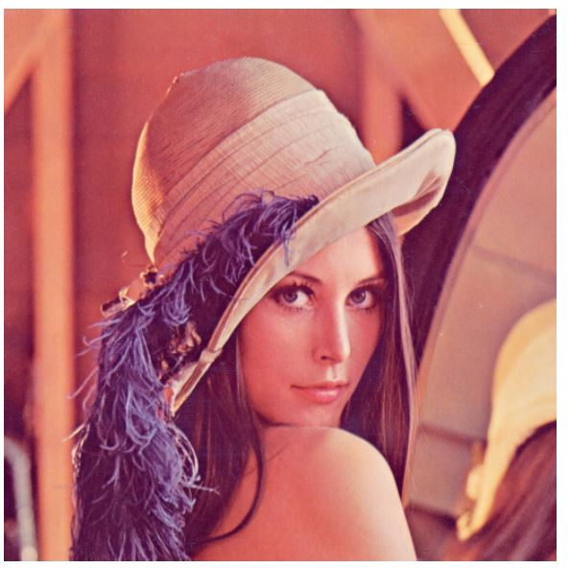

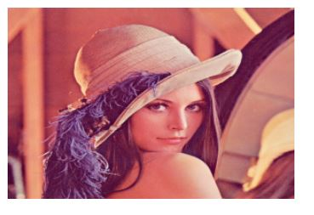

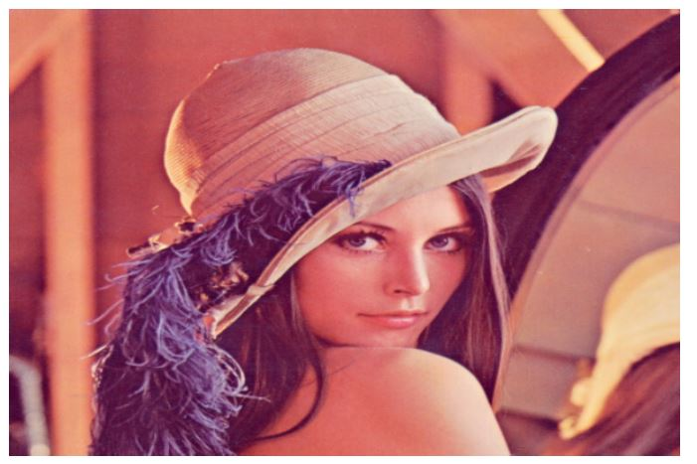

Resizing the image using scaling factor:

Code:

# Scaling Up the image 1.2 times by specifying both scaling factors

scale\_up\_x = 1.2

scale\_up\_y = 1.2

# Scaling Down the image 0.6 times specifying a single scale factor.

scale\_down = 0.6

scaled\_f\_down = cv2.resize(image, None, fx= scale\_down, fy= scale\_down, interpolation= cv2.INTER\_LINEAR)

scaled\_f\_up = cv2.resize(image, None, fx= scale\_up\_x, fy= scale\_up\_y, interpolation= cv2.INTER\_LINEAR)

\*\*\*\*\*\*(replace these lines with line 5 to 12 in the previous program) \*\*\*\*\*\*

# Display images and press any key to check next image

cv2\_imshow(scaled\_f\_down)

cv2.waitKey()

cv2\_imshow(scaled\_f\_up)

cv2.waitKey()

\*\*\*\*\*(replace this line with 13 and 14 in the previous program) \*\*\*\*\*\*\*

exp:

line 1,2: defining the scaling up factor for the image.

line 3: defining the scale down factor for the image.

Line 4,5: use resize function to scale up and scale down the image respectively.

Line 6,8: display the image of scale up and scale down.

**Scaling Factor** or Scale Factor is usually a **number** that **scales or multiplies** some **quantity**, in our case the **width and height** of the image. It helps keep the **aspect ratio**intact and preserves the display quality. So the image does **not appear distorted,** while you are **upscaling** or **downscaling** it.

* We define new scaling factors along the **horizontal** and **vertical** axis.
* Defining the scaling factors removes the need to have new points for width and height. Hence, we keep ***dsize*** as **None.**

Output:

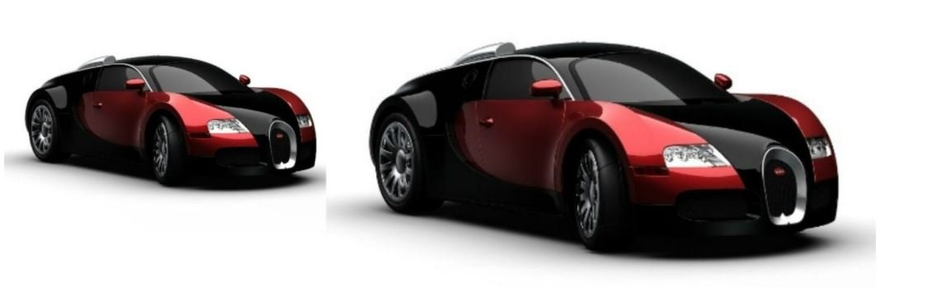

Resizing the image with different interpolation method:

Code:

# Scaling Down the image 0.6 times using different Interpolation Method

res\_inter\_nearest = cv2.resize(image, None, fx= scale\_down, fy= scale\_down, interpolation= cv2.INTER\_NEAREST)

res\_inter\_linear = cv2.resize(image, None, fx= scale\_down, fy= scale\_down, interpolation= cv2.INTER\_LINEAR)

res\_inter\_area = cv2.resize(image, None, fx= scale\_down, fy= scale\_down, interpolation= cv2.INTER\_AREA)

# Concatenate images in horizontal axis for comparison

vertical= np.concatenate((res\_inter\_nearest, res\_inter\_linear, res\_inter\_area), axis = 0)

# Display the image Press any key to continue

cv2\_imshow(vertical)

exp:

Different interpolation methods are used for different resizing purposes.

* **INTER\_AREA:** INTER\_AREA uses pixel area relation for resampling. This is best suited for reducing the size of an image (shrinking). When used for zooming into the image, it uses the INTER\_NEAREST method.
* **INTER\_CUBIC:**This uses bicubic interpolation for resizing the image. While resizing and interpolating new pixels, this method acts on the 4×4 neighboring pixels of the image. It then takes the weights average of the 16 pixels to create the new interpolated pixel.
* **INTER\_LINEAR**: This method is somewhat similar to the INTER\_CUBIC interpolation. But unlike INTER\_CUBIC, this uses 2×2 neighboring pixels to get the weighted average for the interpolated pixel.
* **INTER\_NEAREST**: The INTER\_NEAREST method uses the nearest neighbor concept for interpolation. This is one of the simplest methods, using only one neighboring pixel from the image for interpolation.

line 1,2,3: using the resize function to resize the image

line 4: concatenate or join all the resized image.

Line 5: display the image.

Output:

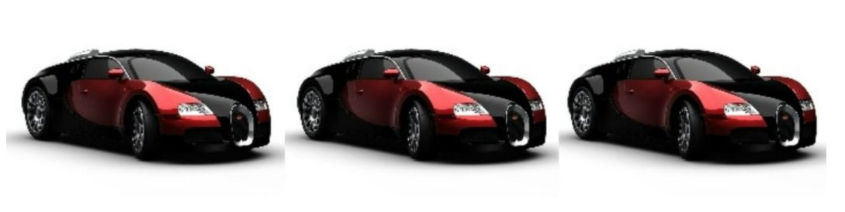

Cropping image using opencv

Code:

# Import packages

import cv2

import numpy as np

img = cv2.imread('lena.jpg')

print(img.shape) # Print image shape

cv2\_imshow(img)

# Cropping an image

cropped\_image = img[80:280, 150:330]

# Display cropped image

print("\n")

cv2\_imshow(cropped\_image)

# Save the cropped image

cv2.imwrite("Cropped Image.jpg", cropped\_image)

cv2.waitKey(0)

cv2.destroyAllWindows()

exp:

line 1,2: importing the libraries.

Line 3: read the image.

Line 4: print the image size.

Line 5: display the original image.

Line 6: by using the matrix values that need to crop assign then to a variable.

Line 7: display the cropped image.

Line 8: write the cropped image.

Output:

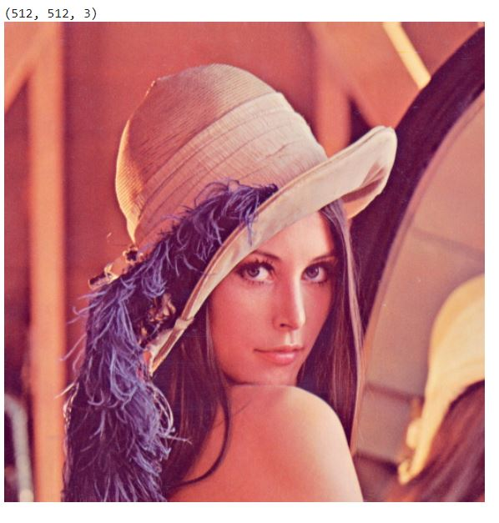

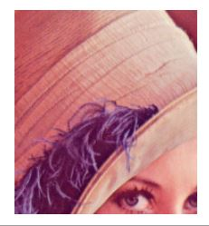

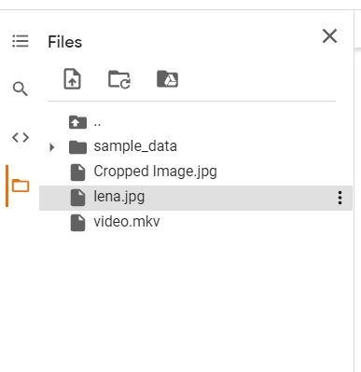

Dividing the image in to patches using cropping:

Code:

img =  cv2.imread("lena.jpg")

image\_copy = img.copy()

imgheight=img.shape[0]

imgwidth=img.shape[1]

M = 73

N = 73

x1 = 0

y1 = 0

for y in range(0, imgheight, M):

    for x in range(0, imgwidth, N):

        if (imgheight - y) < M or (imgwidth - x) < N:

            break

        y1 = y + M

        x1 = x + N

        # check whether the patch width or height exceeds the image width or height

        if x1 >= imgwidth and y1 >= imgheight:

            x1 = imgwidth - 1

            y1 = imgheight - 1

            #Crop into patches of size MxN

            tiles = image\_copy[y:y+M, x:x+N]

            #Save each patch into file directory

            cv2.imwrite('saved\_patches/'+'tile'+str(x)+'\_'+str(y)+'.jpg', tiles)

            cv2.rectangle(img, (x, y), (x1, y1), (0, 255, 0), 1)

        elif y1 >= imgheight: # when patch height exceeds the image height

            y1 = imgheight - 1

            #Crop into patches of size MxN

            tiles = image\_copy[y:y+M, x:x+N]

            #Save each patch into file directory

            cv2.imwrite('saved\_patches/'+'tile'+str(x)+'\_'+str(y)+'.jpg', tiles)

            cv2.rectangle(img, (x, y), (x1, y1), (0, 255, 0), 1)

        elif x1 >= imgwidth: # when patch width exceeds the image width

            x1 = imgwidth - 1

            #Crop into patches of size MxN

            tiles = image\_copy[y:y+M, x:x+N]

            #Save each patch into file directory

            cv2.imwrite('saved\_patches/'+'tile'+str(x)+'\_'+str(y)+'.jpg', tiles)

            cv2.rectangle(img, (x, y), (x1, y1), (0, 255, 0), 1)

        else:

            #Crop into patches of size MxN

            tiles = image\_copy[y:y+M, x:x+N]

            #Save each patch into file directory

            cv2.imwrite('saved\_patches/'+'tile'+str(x)+'\_'+str(y)+'.jpg', tiles)

            cv2.rectangle(img, (x, y), (x1, y1), (0, 255, 0), 1)

cv2\_imshow(img)

cv2.imwrite("patched.jpg",img)

exp:

line 1: reading the image.

Line 2: coping the image to another variable.

Line 3: getting image height using shape function.

Line 4: getting image width using shape function.

Line 5,6: declare the values for the size of patches to create.

Line 7: open for loop to run the loop from the beginning of the height till the end of the height of the image. to check the height of the image whether it exceeds the given value or not.

Line 8: open an another for loop to run the loop from the beginning width of the image till the end of width of the image. to check width of the image whether it exceeds the given value or not.

Line 9: check whether the height or the width of the patch is lesser than the image size.

Line 10: if yes break and moves to next statement.

Line 11,12: or else it will add the height and width value with the zero initialized variable to check for next time.

Line 13: check the values of x1 and y1 are greater or equal to the imgheight and imgwidth to ensure draw the patches not across the image.

Line 14,15: if it is true then subtract value 1 from both width and height.

Line 16: crop the image in to patch size of M x N.

Line 17: save each patch in a file dictionary.

Line 18: repeating the process till patch size exceeding the height of the image.

Line 19 - 28: repeat the same process for the width and patch formation and until it exceeds the width of the image.

Line 29: display the image.

Line 30: write the image.

Output:

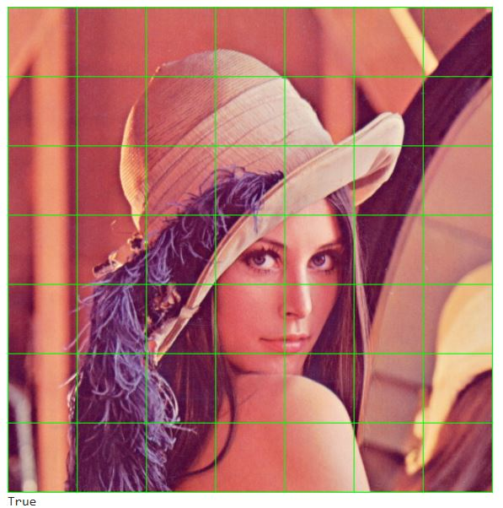

Rotation of image using open cv:

Code:

import cv2

# Reading the image

image = cv2.imread('lena.jpg')

# dividing height and width by 2 to get the center of the image

height, width = image.shape[:2]

# get the center coordinates of the image to create the 2D rotation matrix

center = (width/2, height/2)

# using cv2.getRotationMatrix2D() to get the rotation matrix

rotate\_matrix = cv2.getRotationMatrix2D(center=center, angle=45, scale=1)

# rotate the image using cv2.warpAffine

rotated\_image = cv2.warpAffine(src=image, M=rotate\_matrix, dsize=(width, height))

cv2\_imshow(image)

print("\n")

cv2\_imshow(rotated\_image)

# wait indefinitely, press any key on keyboard to exit

cv2.waitKey(0)

# save the rotated image to disk

cv2.imwrite('rotated\_image.jpg', rotated\_image)

exp:

OpenCV provides the getRotationMatrix2D() function to create the above transformation matrix.

The following is the syntax for creating the 2D rotation matrix:

getRotationMatrix2D(center, angle, scale)

The getRotationMatrix2D() function takes the following arguments:

* center: the center of rotation for the input image
* angle: the angle of rotation in degrees
* scale: an isotropic scale factor which scales the image up or down according to the value provided

If the angle is positive, the image gets rotated in the counter-clockwise direction. If you want to rotate the image clockwise by the same amount, then the angle needs to be negative.

Rotation is a three-step operation:

1. First, you need to get the center of rotation. This typically is the center of the image you are trying to rotate.
2. Next, create the 2D-rotation matrix. OpenCV provides the getRotationMatrix2D() function that we discussed above.
3. Finally, apply the affine transformation to the image, using the rotation matrix you created in the previous step. The warpAffine() function in OpenCV does the job.

The warpAffine() function applies an affine transformation to the image. After applying affine transformation, all the parallel lines in the original image will remain parallel in the output image as well.

The complete syntax for warpAffine() is given below:

warpAffine(src, M, dsize[, dst[, flags[, borderMode[, borderValue]]]])

The following are the arguments of the function:

* src: the source mage
* M: the transformation matrix
* dsize: size of the output image
* dst: the output image
* flags: combination of interpolation methods such as INTER\_LINEAR or INTER\_NEAREST
* borderMode: the pixel extrapolation method
* borderValue: the value to be used in case of a constant border, has a default value of 0

line 1: import the libraries.

Line 2: read the image.

Line 3: get the height and width of the image using shape function.

Line 4: divide width and height by 2 to find the centre of the image and assign it to the centre variable.

Line 5: use rotate matrix function to rotate the values of image in the matrix format.

Line 6: use the rotated matrix value in the warpaffine function with width and height of the image to get the rotated image.

Line 7: display the original image.

Line 8: display the rotated image.

Line 9: save the rotated image.

Output:

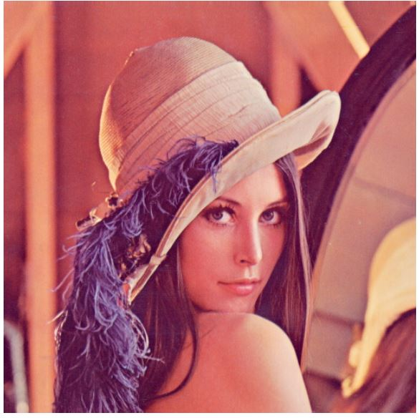

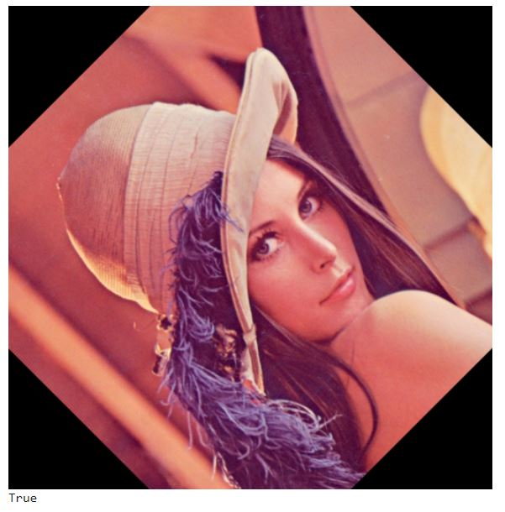

Translation of image using open cv

Code:

import cv2

import numpy as np

# read the image

image = cv2.imread('lena.jpg')

# get the width and height of the image

height, width = image.shape[:2]

# get tx and ty values for translation

# you can specify any value of your choice

tx, ty = width / 4, height / 4

# create the translation matrix using tx and ty, it is a NumPy array

translation\_matrix = np.array([

    [1, 0, tx],

    [0, 1, ty]

], dtype=np.float32)

# apply the translation to the image

translated\_image = cv2.warpAffine(src=image, M=translation\_matrix, dsize=(width, height))

# display the original and the Translated images

cv2\_imshow(translated\_image)

print("\n")

cv2\_imshow(image)

cv2.waitKey(0)

# save the translated image to disk

cv2.imwrite('translated\_image.jpg', translated\_image)

exp:

line 1,2: importing the libraries.

Line 3: read the image.

Line 4: get the height and width of the image.

Line 5: get the value for translation of the image to be done.

Line 6: create a translational matrix using the tx and ty values which it is an numpy array.

Line 7: apply the translational to the image using warpaffine function.

Line 8: display the translated image.

Line 9: display the original image.

Line 10: save the translated image.

Output:

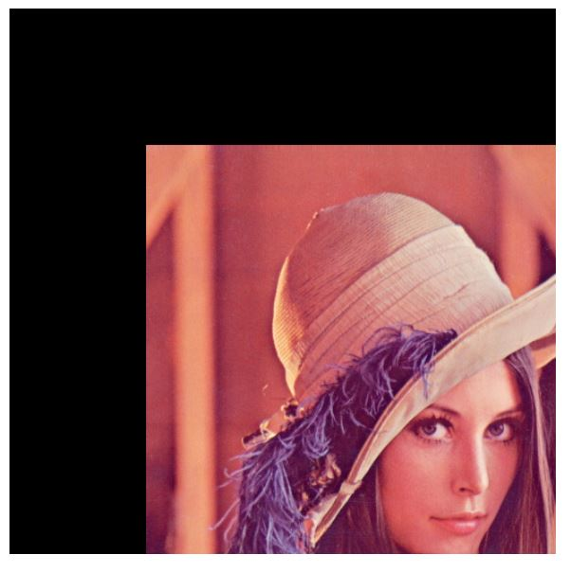

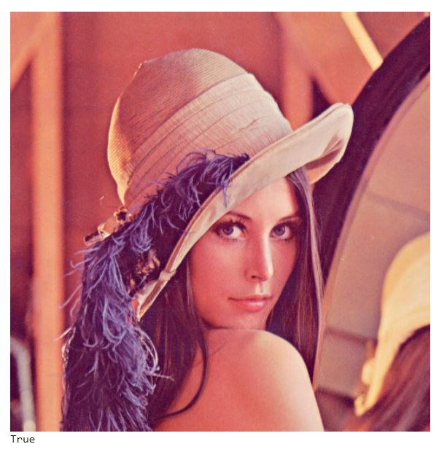

Annotating image using open cv: draw line:

Code:

# Import dependencies

import cv2

# Read Images

img = cv2.imread('lena.jpg')

# Display Image

#cv2\_imshow(img)

cv2.waitKey(0)

# Print error message if image is null

if img is None:

    print('Could not read image')

# Draw line on image

imageLine = img.copy()

#Draw the image from point A to B

pointA = (200,80)

pointB = (450,80)

cv2.line(imageLine, pointA, pointB, (255, 255, 0), thickness=3, lineType=cv2.LINE\_AA)

cv2\_imshow(imageLine)

cv2.waitKey(0)

exp:

the syntax for the line() function:

line(image, start\_point, end\_point, color, thickness)

* The first argument is the image.
* The next two arguments are the starting point and ending point for the line.

Draw a line from point A(x1, y1) to point B(x2, y2), where A and B represent any two points in the image. Look at the top left corner of the image, you’ll find there the origin of the xy coordinate system.

* The x-axis represents the horizontal direction or the columns of the image.
* The y-axis represents the vertical direction or the rows of the image.

As shown in the code below:

* Specify the start and end points, to draw a line that is 250-pixels long, horizontally on the image.
* Specify its color to be a mixture of blue and green, and its thickness is specified as 3.

line 1, 2: importing library and reading the image.

line 4: check for is image is there or not using if condition.

Line 5: if not then print could not read image.

Line 6: if yes then copy image to new variable.

Line 7,8: declare the points to draw the line between the points a and b like (x1, y1) and (x2, y2) respectively.

Line 9: use line function to get line in the image where the points are defined.

Line 10: display the image.

Output:

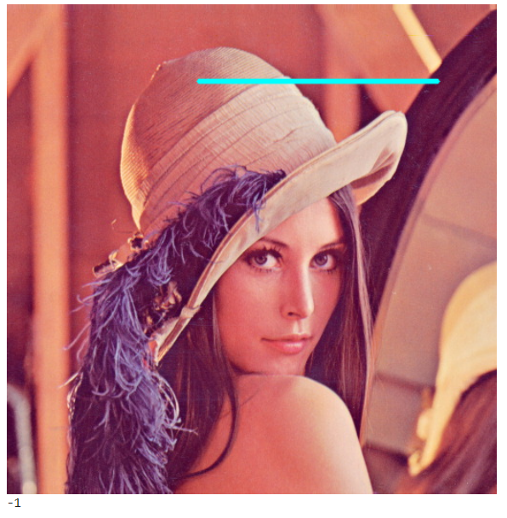

Draw a circle in image:

Code:

# Make a copy of image

imageCircle = img.copy()

# define the center of circle

circle\_center = (300,290)

# define the radius of the circle

radius =100

#  Draw a circle using the circle() Function

cv2.circle(imageCircle, circle\_center, radius, (0, 0, 255), thickness=3, lineType=cv2.LINE\_AA)

# Display the result

cv2\_imshow(imageCircle)

cv2.waitKey(0)

exp:

its syntax:

circle(image, center\_coordinates, radius, color, thickness)

* As with all drawing functions in OpenCV, the first argument is the image.
* The next two arguments define the coordinates for the center of the circle and its radius.
* The last two arguments specify the color and thickness of the line.

line 1: copy image to new variable.

Line 2: declare the centre of the circle.

Line 3: declare the radius for the circle.

Line 4: use circle function to draw circle in the image.

Line 5: display the image.

Output:

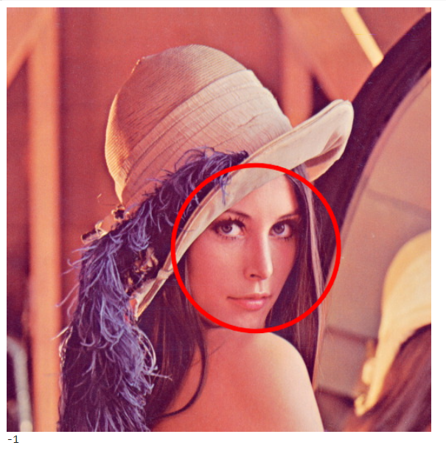

Draw a filled circle in the image:

Code:

# make a copy of the original image

imageFilledCircle = img.copy()

# define center of the circle

circle\_center = (300,290)

# define the radius of the circle

radius =100

# draw the filled circle on input image

cv2.circle(imageFilledCircle, circle\_center, radius, (255, 0, 0), thickness=-1, lineType=cv2.LINE\_AA)

# display the output image

cv2\_imshow(imageFilledCircle)

cv2.waitKey(0)

exp:

just change the change the thickness value to -1 to fill inside the circle.

Output:

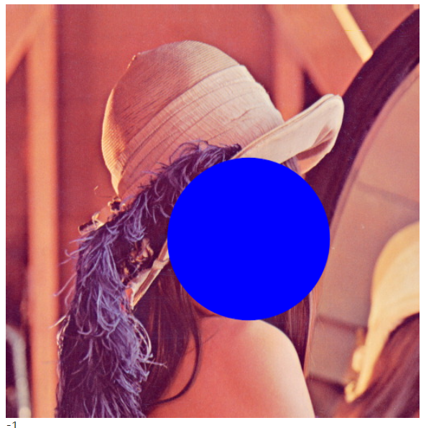

Draw a rectangle in the image:

Code:

# make a copy of the original image

imageRectangle = img.copy()

# define the starting and end points of the rectangle

start\_point =(150,150)

end\_point =(400,390)

# draw the rectangle

cv2.rectangle(imageRectangle, start\_point, end\_point, (0, 0, 255), thickness= 3, lineType=cv2.LINE\_8)

# display the output

cv2\_imshow(imageRectangle)

cv2.waitKey(0)

exp:

just as same as line give start and end points and use the rectangle function to draw it.

 its syntax:

rectangle(image, start\_point, end\_point, color, thickness)

In the rectangle() function, you provide the starting point (top left) and ending point (bottom right) for the corners of the rectangle.

Output:

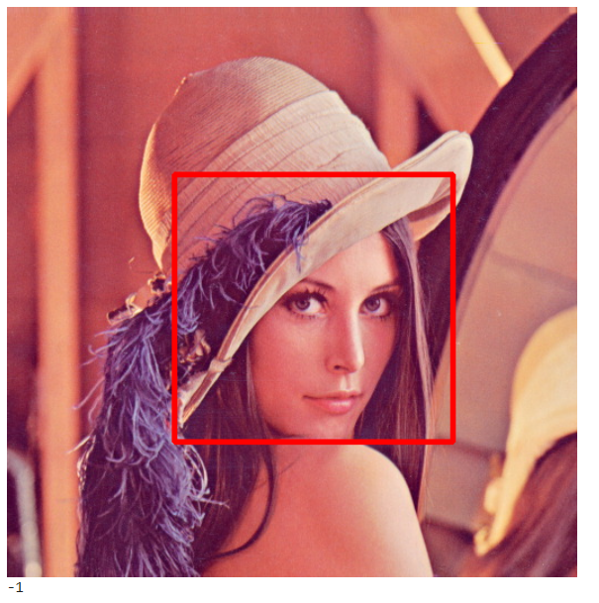

The different colour spaces:

Code:

cube1=files.upload()

cube2=files.upload()

bright = cv2.imread('cube1.JPG')

dark = cv2.imread('cube2.JPG')

exp:

upload the files and read it in bright and dark.

Output:

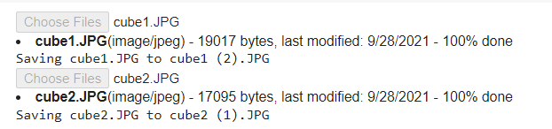

Code:

cv2\_imshow(bright)

cv2\_imshow(dark)

exp: display the images to verify it.

Output:

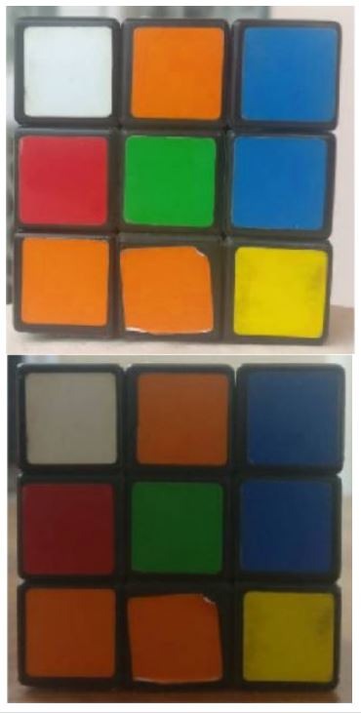

The LAB colour space:

Code:

brightLAB = cv2.cvtColor(bright, cv2.COLOR\_BGR2LAB)

darkLAB = cv2.cvtColor(dark, cv2.COLOR\_BGR2LAB)

cv2\_imshow(brightLAB)

cv2\_imshow(darkLAB)

exp:

convert the bright and dark image to LAB colour format and display it.

**The LAB Color-Space**

The Lab color space has three components.

1. L – Lightness ( Intensity ).
2. a – color component ranging from Green to Magenta.
3. b – color component ranging from Blue to Yellow.

The Lab color space is quite different from the RGB color space. In RGB color space the color information is separated into three channels but the same three channels also encode brightness information. On the other hand, in Lab color space, the L channel is independent of color information and encodes brightness only. The other two channels encode color.

It has the following properties.

* Perceptually uniform color space which approximates how we perceive color.
* Independent of device ( capturing or displaying ).
* Used extensively in Adobe Photoshop.
* Is related to the RGB color space by a complex transformation equation.

Output:

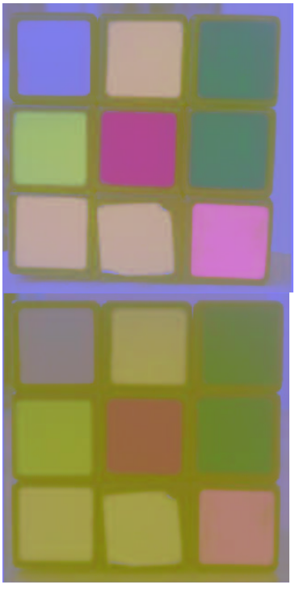

The Y Cr Cb colour space:

Code:

brightYCB = cv2.cvtColor(bright, cv2.COLOR\_BGR2YCrCb)

darkYCB = cv2.cvtColor(dark, cv2.COLOR\_BGR2YCrCb)

cv2\_imshow(brightYCB)

cv2\_imshow(darkYCB)

exp:

convert the bright and dark images to YCrCb format and display it.

**The YCrCb Color-Space**

The YCrCb color space is derived from the RGB color space and has the following three compoenents.

1. Y – Luminance or Luma component obtained from RGB after gamma correction.
2. Cr = R – Y ( how far is the red component from Luma ).
3. Cb = B – Y ( how far is the blue component from Luma ).

This color space has the following properties.

* Separates the luminance and chrominance components into different channels.
* Mostly used in compression ( of Cr and Cb components ) for TV Transmission.
* Device dependent.

Output:

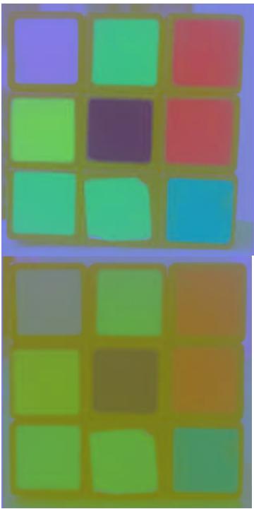

The HSC colour scale:

Code:

brightHSV = cv2.cvtColor(bright, cv2.COLOR\_BGR2HSV)

darkHSV = cv2.cvtColor(dark, cv2.COLOR\_BGR2HSV)

cv2\_imshow(brightHSV)

cv2\_imshow(darkHSV)

exp:

convert the bright and dark images to HSV format and display it.

**The HSV Color Space**

The HSV color space has the following three components

1. H – Hue ( Dominant Wavelength ).
2. S – Saturation ( Purity / shades of the color ).
3. V – Value ( Intensity ).

Let’s enumerate some of its properties.

* Best thing is that it uses only one channel to describe color (H), making it very intuitive to specify color.
* Device dependent.

Output:

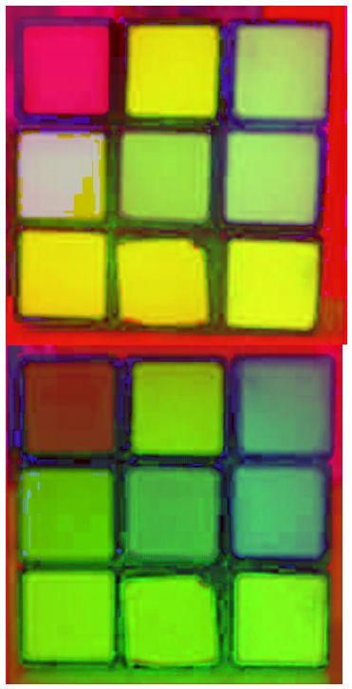

Using the colour spaces for segmentation:

Code:

bgr = [40, 158, 16]

thresh = 40

minBGR = np.array([bgr[0] - thresh, bgr[1] - thresh, bgr[2] - thresh])

maxBGR = np.array([bgr[0] + thresh, bgr[1] + thresh, bgr[2] + thresh])

maskBGR = cv2.inRange(bright,minBGR,maxBGR)

resultBGR = cv2.bitwise\_and(bright, bright, mask = maskBGR)

#convert 1D array to 3D, then convert it to HSV and take the first element

# this will be same as shown in the above figure [65, 229, 158]

hsv = cv2.cvtColor( np.uint8([[bgr]] ), cv2.COLOR\_BGR2HSV)[0][0]

minHSV = np.array([hsv[0] - thresh, hsv[1] - thresh, hsv[2] - thresh])

maxHSV = np.array([hsv[0] + thresh, hsv[1] + thresh, hsv[2] + thresh])

maskHSV = cv2.inRange(brightHSV, minHSV, maxHSV)

resultHSV = cv2.bitwise\_and(brightHSV, brightHSV, mask = maskHSV)

#convert 1D array to 3D, then convert it to YCrCb and take the first element

ycb = cv2.cvtColor( np.uint8([[bgr]] ), cv2.COLOR\_BGR2YCrCb)[0][0]

minYCB = np.array([ycb[0] - thresh, ycb[1] - thresh, ycb[2] - thresh])

maxYCB = np.array([ycb[0] + thresh, ycb[1] + thresh, ycb[2] + thresh])

maskYCB = cv2.inRange(brightYCB, minYCB, maxYCB)

resultYCB = cv2.bitwise\_and(brightYCB, brightYCB, mask = maskYCB)

#convert 1D array to 3D, then convert it to LAB and take the first element

lab = cv2.cvtColor( np.uint8([[bgr]] ), cv2.COLOR\_BGR2LAB)[0][0]

minLAB = np.array([lab[0] - thresh, lab[1] - thresh, lab[2] - thresh])

maxLAB = np.array([lab[0] + thresh, lab[1] + thresh, lab[2] + thresh])

maskLAB = cv2.inRange(brightLAB, minLAB, maxLAB)

resultLAB = cv2.bitwise\_and(brightLAB, brightLAB, mask = maskLAB)

cv2\_imshow(resultBGR)

cv2\_imshow(resultHSV)

cv2\_imshow(resultYCB)

cv2\_imshow(resultLAB)

exp:

**Step 1: Get the color values for a particular color**

Find the approximate range of values of green color for each color space. For doing this, I’ve made an interactive GUI where you can check the values of all the color spaces for each pixel just by hovering the mouse on the image as shown below:

[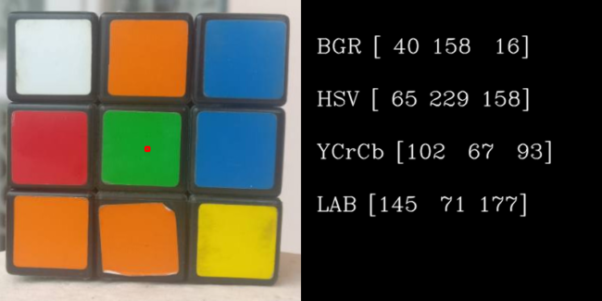](https://learnopencv.com/wp-content/uploads/2017/05/color-values-4-rub08-e1493874642781.png)Demo showing a pixel and its value in different color spaces for the Outdoor image.

**Step 2: Applying threshold for segmentation**

Extract all pixels from the image which have values close to that of the green pixel. We can take a range of +/- 40 for each color space and check how the results look like. We will use the opencv function inRange for finding the mask of green pixels and then use bitwise\_and operation to get the green pixels from the image using the mask.

Line 1,2: fixing values for BGR and thresh value.

Line 3,4: defining min and max BGR array using numpy.

Line 7-11: converting single dimensional array to three-dimensional array and converting it to HSV format and taking the first element of the array and assigning it in mask HSV array.

Line 12-16: repeat the same previous process but instead of converting to HSV convert it to YCrCb format and store it in the maskYCB array.

Line 17- 21: repeat the same process but convert it to LAB fromat.

Line 22-25: display all the resulted images.

Output:

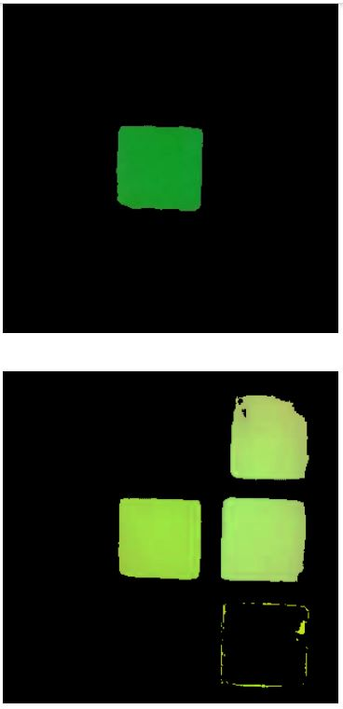

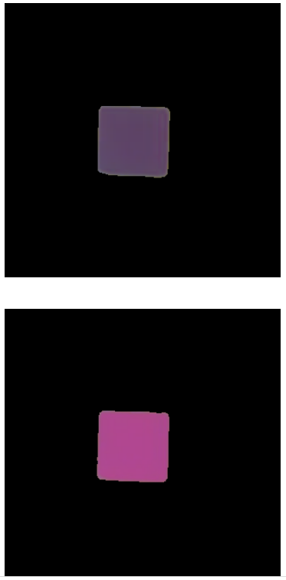

Image filtering using convolution in opencv:

Code:

import cv2

import numpy as np

image = cv2.imread('test.JPG')

# Print error message if image is null

if image is None:

    print('Could not read image')

# Apply identity kernel

kernel1 = np.array([[0, 0, 0],

                    [0, 1, 0],

                    [0, 0, 0]])

identity = cv2.filter2D(src=image, ddepth=-1, kernel=kernel1)

cv2\_imshow(image)

print("\n")

cv2\_imshow(identity)

print("\n")

cv2.waitKey()

cv2.imwrite('identity.jpg', identity)

cv2.destroyAllWindows()

# Apply blurring kernel

kernel2 = np.ones((5, 5), np.float32) / 25

img = cv2.filter2D(src=image, ddepth=-1, kernel=kernel2)

cv2\_imshow(image)

print("\n")

cv2\_imshow(img)

cv2.waitKey()

cv2.imwrite('blur\_kernel.jpg', img)

cv2.destroyAllWindows()

exp:

line 1,2: importing the libraries.

Line 3: read the image.

Line 4: check for image is present or opening.

Line 5: create an identity kernel array using numpy.

Line 6: apply the identity kernel to the image with 2D matrix.

Line 7,8: show the original image and identity applied image.

Line 9: save the identity image.

Line 10,11: apply blurring kernel to the image.

Line 12,13: show the original image and blurred image.

Line 14: wave the blurred image.

To know more visit: <https://learnopencv.com/image-filtering-using-convolution-in-opencv/>

Output:

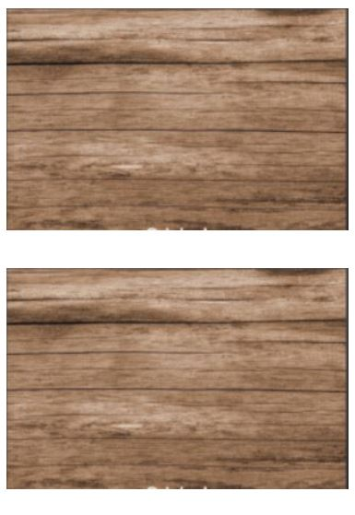

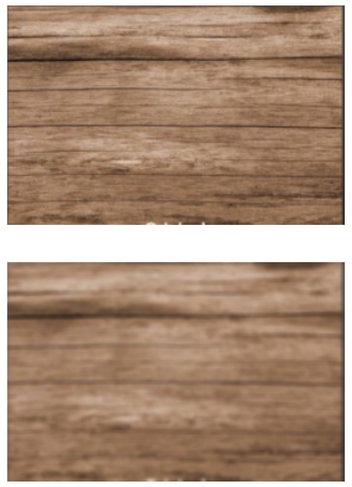

Blurring an image using opencv built in function

Code:

img\_blur = cv2.blur(src=image, ksize=(5,5)) # Using the blur function to blur an image where ksize is the kernel size

# Display using cv2.imshow()

cv2\_imshow(image)

print("\n")

cv2\_imshow(img\_blur)

cv2.waitKey()

cv2.imwrite('blur.jpg', img\_blur)

cv2.destroyAllWindows()

exp:

OpenCV’s built-in **blur()**function. Essentially a convenience function, use it to blur images, where you need not specifically define a kernel.  Simply specify the kernel size, using the **ksize** input argument, as shown in the code below. The blur function will then internally create a 5×5 blur kernel, and apply it to the source image.

The example above, which uses the **blur()**function will generate exactly the same output as the example above, which had used  the **filter2d()**function.

Output:

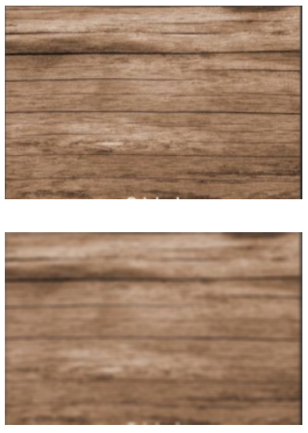

Applying gaussian blur to an image in opencv

Code:

# sigmaX is Gaussian Kernel standard deviation

# ksize is kernel size

gaussian\_blur = cv2.GaussianBlur(src=image, ksize=(5,5), \

sigmaX=0, sigmaY=0)

cv2\_imshow(image)

print("\n")

cv2\_imshow( gaussian\_blur)

cv2.waitKey()

cv2.imwrite('gaussian\_blur.jpg', gaussian\_blur)

cv2.destroyAllWindows()

exp:

Gaussian blur to an image, using OpenCV. This technique uses a Gaussian filter, which performs a weighted average, as opposed to the uniform average described in the first example. In this case, the Gaussian blur weights pixel values, based on their distance from the center of the kernel. Pixels further from the center have less influence on the weighted average. The following code convolves an image, using the **GaussianBlur()**function in OpenCV.

GaussianBlur(src, ksize, sigmaX[, dst[, sigmaY[, borderType]]])

The **GaussianBlur()**function requires four input arguments:

* The first argument, **src**, specifies the source image that you want to filter.
* The second argument is **ksize**, which defines the size of the Gaussian kernel. Here, we are using a 5×5 kernel.
* The final two arguments are **sigmaX** and **sigmaY**, which are both set to 0. These are the Gaussian kernel standard deviations, in the X (horizontal) and Y (vertical) direction. The default setting of **sigmaY** is zero. If you simply  set **sigmaX** to zero, then the standard deviations are computed from the kernel size (width and height respectively). You can also explicitly set the size of each argument to positive values greater than zero.

Output:

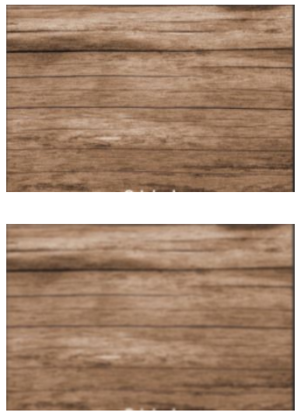

Applying median blurring to the image using opencv

Code:

# medianBlur() is used to apply Median blur to image

# ksize is the kernel size

median = cv2.medianBlur(src=image, ksize=5)

cv2\_imshow(image)

print("\n")

cv2\_imshow(median)

cv2.waitKey()

cv2.imwrite('median\_blur.jpg', median)

cv2.destroyAllWindows()

exp:

apply median blurring, using the **medianBlur()**function in OpenCV. In median blurring, each pixel in the source image is replaced by the median value of the image pixels in the kernel area.

medianBlur(src, ksize)

This function has just two required arguments:

* The first is the source image.
* The second is the kernel size, which must be an odd, positive integer.

Output:

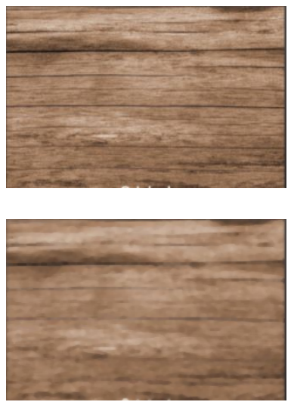

Sharpening the image using custom 2-D convolution kernel

Code:

kernel3 = np.array([[0, -1,  0],

                   [-1,  5, -1],

                    [0, -1,  0]])

sharp\_img = cv2.filter2D(src=image, ddepth=-1, kernel=kernel3)

cv2\_imshow(image)

print("\n")

cv2\_imshow(sharp\_img)

cv2.waitKey()

cv2.imwrite('sharp\_image.jpg', sharp\_img)

cv2.destroyAllWindows()

exp:

sharpen an image with a 2D-convolution kernel. First define a custom 2D kernel, and then use the **filter2D()**function to apply the convolution operation to the image.

In the code below, the 3×3 kernel defines a sharpening kernel

Line 1: defining the kernel array for sharpening the image using numy .

Line 2: use filter 2-D function to sharpen the image.

Line 3,4: show the original and sharpen image.

Output:

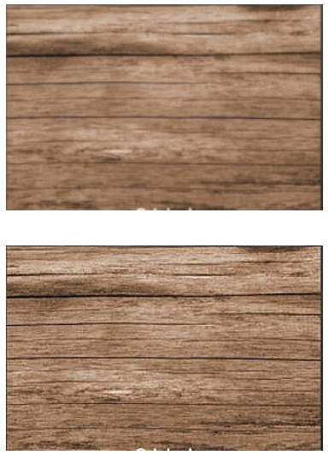

Applying bilateral filtering to the image using open cv

Code:

# Using the function bilateralFilter() where d is diameter of each...

# ...pixel neighborhood that is used during filtering.

# sigmaColor is used to filter sigma in the color space.

# sigmaSpace is used to filter sigma in the coordinate space.

bilateral\_filter = cv2.bilateralFilter(src=image, d=9, sigmaColor=75, sigmaSpace=75)

cv2\_imshow(image)

print("\n")

cv2\_imshow(bilateral\_filter)

cv2.waitKey(0)

cv2.imwrite('bilateral\_filtering.jpg', bilateral\_filter)

cv2.destroyAllWindows()

exp:

While blurring can be an effective way to reduce noise in an image, it is often not desirable to blur the entire image, as important details and sharp edges may be lost. In such cases, ***bilateral filtering*** can make your life easier.

* This technique applies the filter selectively to blur similar intensity pixels in a neighborhood. Sharp edges are preserved, wherever possible.
* It lets you control not only the spatial size of the filter, but also the degree to which the neighboring pixels are included in the filtered output. This is done, based on variation in their color intensity, and also distance from the filtered pixel.

Bilateral filtering essentially applies a 2D Gaussian (weighted) blur to the image, while also considering the variation in intensities of neighboring pixels to minimize the blurring near edges (which we wish to preserve). What this means is that the shape of the kernel actually depends on the local image content, at every pixel location.

Here’s a concrete example. Assume, you are filtering a region in an image, near an edge. A simple Gaussian blur filter would blur the edge because it lies near the filtered region (close to the center of the Gaussian filter).  But the bilateral filter can sense the edge, because it also considers differences in pixel intensities. So, it will compute a much lower weight for the pixels straddling the edge, thereby reducing their influence on the filtered region. Regions of more uniform intensity are blurred heavier, as they are not associated with strong edges.

Thankfully, OpenCV provides the **bilateralFilter()** function to filter images.

bilateralFilter(src, d, sigmaColor, sigmaSpace)

This function has four required arguments:

* The first argument of the function is the source image.
* The next argument d, defines the diameter of the pixel neighborhood used for filtering.
* The next two arguments, **sigmaColor** and **sigmaSpace** define the standard deviation of the (1D) color-intensity distribution and (2D) spatial distribution respectively.
  + The **sigmaSpace** parameter defines the spatial extent of the kernel, in both the x and y directions (just like the Gaussian blur filter previously described).
  + The **sigmaColor** parameter defines the one-dimensional Gaussian distribution, which specifies the degree to which differences in pixel intensity can be tolerated.

The final (weighted) value for a pixel in the filtered image is a product of its spatial and intensity weight. Thus,

* pixels that are similar and near the filtered pixel will have influence
* pixels that are far away from the filtered pixel will have little influence (due to the spatial Gaussian)
* pixels that have dissimilar intensities will have little influence (due to the color-intensity Gaussian), even if they are close to the center of the kernel.

Output:

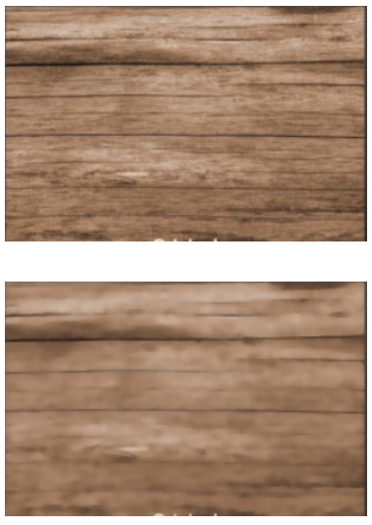

Threshold in images using open cv

Code:

# import opencv

import cv2

# Read image

src = cv2.imread("image.jpg", cv2.IMREAD\_GRAYSCALE);

cv2\_imshow(src)

# Basic threhold example

th, dst = cv2.threshold(src, 0, 255, cv2.THRESH\_BINARY);

print("\n")

cv2\_imshow(dst);

# Thresholding with maxValue set to 128

th, dst = cv2.threshold(src, 0, 128, cv2.THRESH\_BINARY);

print("\n")

cv2\_imshow(dst);

# Thresholding with threshold value set 127

th, dst = cv2.threshold(src,127,255, cv2.THRESH\_BINARY);

print("\n")

cv2\_imshow(dst);

# Thresholding using THRESH\_BINARY\_INV

th, dst = cv2.threshold(src,127,255, cv2.THRESH\_BINARY\_INV);

print("\n")

cv2\_imshow(dst);

# Thresholding using THRESH\_TRUNC

th, dst = cv2.threshold(src,127,255, cv2.THRESH\_TRUNC);

print("\n")

cv2\_imshow(dst);

# Thresholding using THRESH\_TOZERO

th, dst = cv2.threshold(src,127,255, cv2.THRESH\_TOZERO);

print("\n")

cv2\_imshow(dst);

# Thresholding using THRESH\_TOZERO\_INV

th, dst = cv2.threshold(src,127,255, cv2.THRESH\_TOZERO\_INV);

cv2\_imshow(dst);

exp:

line 1,2,3: importing the library and reading the image and displaying it.

Line 4,5: basic thresholding using threshold function of type thresh binary scale and display the image.

Line 6,7: basic thresholding with maximum value set to 128 and display the image.

Line 8,9: thresholding the image with value set to 127 and display the image.

Line 10, 11: thresholding using thresh binary inverse type and display the image.

Line 12,13: thresholding the image using thresh truncate and display it.

Line 15,16: thresholding using thresh to zero and display the image.

Line 17,18: thresholding using thresh to zero inverse and display the image.

Output:

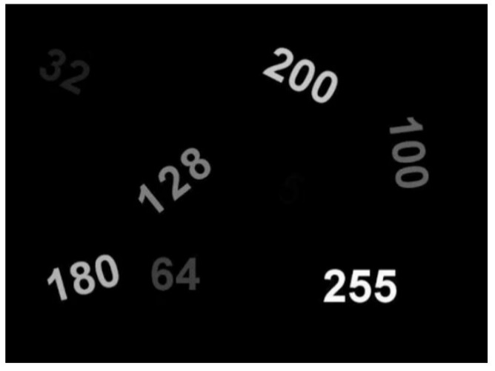

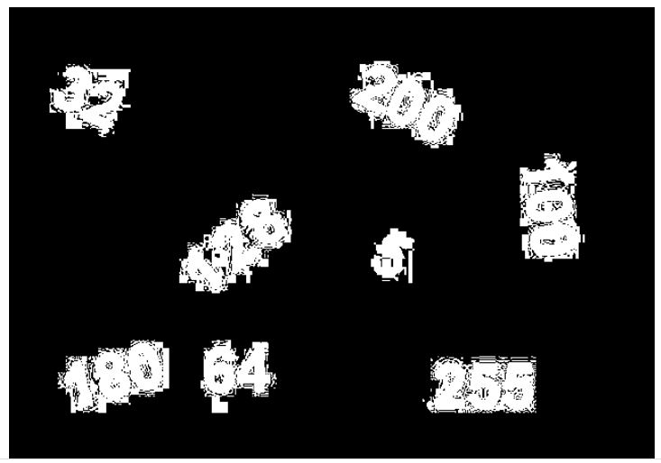

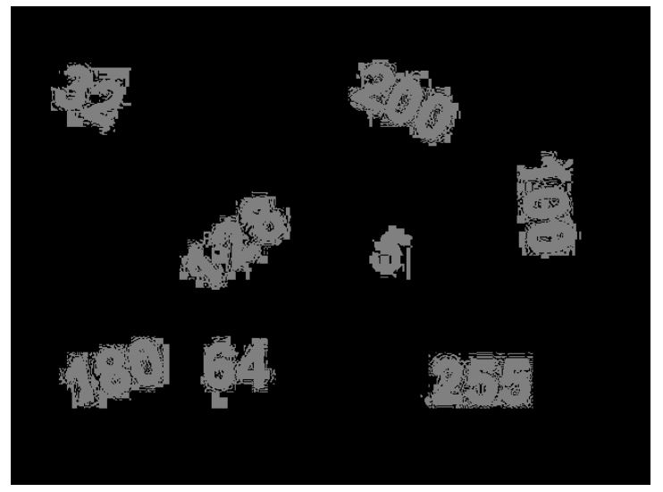

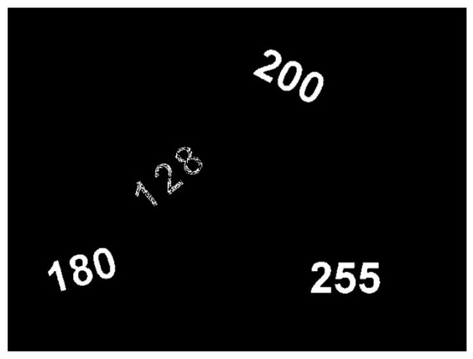

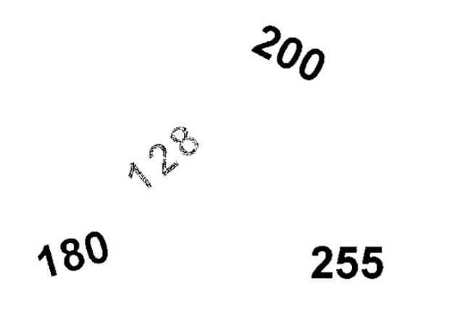

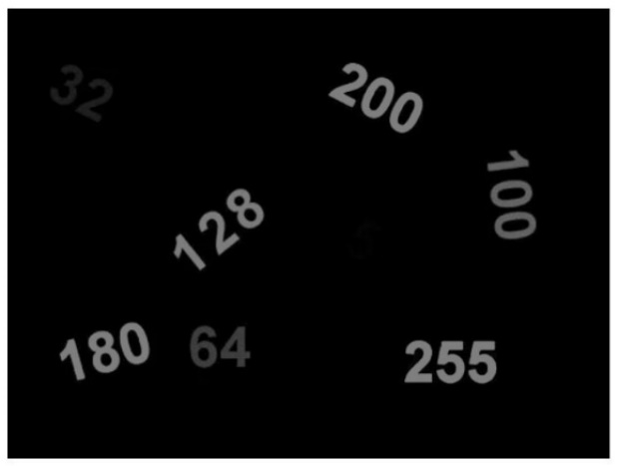

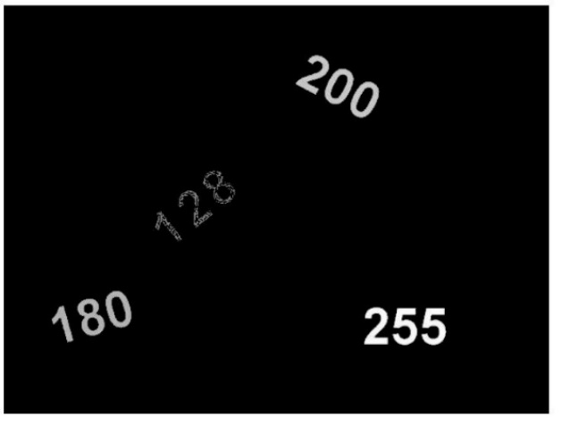

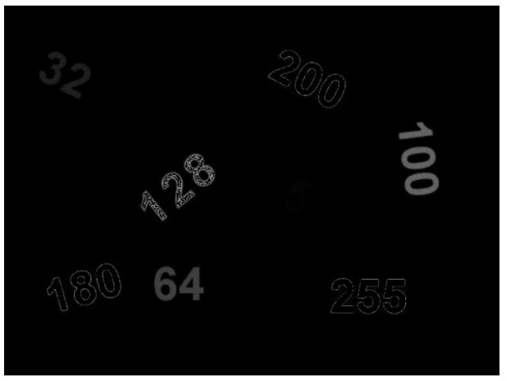

Blob detection in image using open cv:

Code:

import cv2

import numpy as np;

# Read image

im = cv2.imread("blob.jpg", cv2.IMREAD\_GRAYSCALE)

# Set up the detector with default parameters.

detector = blob\_detector = cv2.SimpleBlobDetector\_create()

# Detect blobs.

keypoints = detector.detect(im)

# Draw detected blobs as red circles.

# cv2.DRAW\_MATCHES\_FLAGS\_DRAW\_RICH\_KEYPOINTS ensures the size of the circle corresponds to the size of blob

im\_with\_keypoints = cv2.drawKeypoints(im, keypoints, np.array([]), (0,0,255),

cv2.DRAW\_MATCHES\_FLAGS\_DRAW\_RICH\_KEYPOINTS)

# Show keypoints

cv2\_imshow(im\_with\_keypoints)

cv2.waitKey(0)

exp:

A Blob is a group of connected pixels in an image that share some common property ( E.g grayscale value ). In the image above, the dark connected regions are blobs, and the goal of blob detection is to identify and mark these regions.

**How does Blob detection work ?**

SimpleBlobDetector, as the name implies, is based on a rather simple algorithm described below. The algorithm is controlled by parameters ( shown in bold below )  and has the following steps. Scroll down to know how the parameters are set.

1. **Thresholding :** Convert the source images to *several* binary images by thresholding the source image with thresholds starting at **minThreshold**. These thresholds are incremented  by **thresholdStep** until **maxThreshold**. So the first threshold is **minThreshold,**the second is **minThreshold**+ **thresholdStep,**the third is **minThreshold**+ **2 x thresholdStep**, and so on.
2. **Grouping :**In each binary image,  connected white pixels are grouped together.  Let’s call these binary blobs.
3. **Merging**  : The centers of the binary blobs in the binary images are computed, and  blobs located closer than **minDistBetweenBlobs**are merged.
4. **Center & Radius Calculation :** The centers and radii of the new merged blobs are computed and returned.

Output:

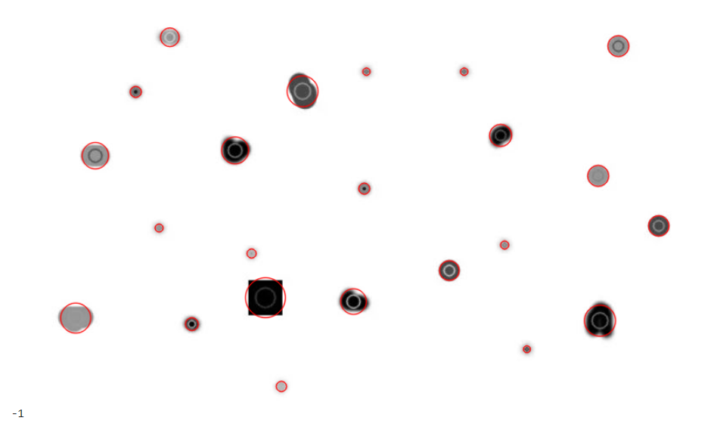

Filtering blob using colour, size and shape:

Code:

# Setup SimpleBlobDetector parameters.

im = cv2.imread("blob.jpg", cv2.IMREAD\_GRAYSCALE)

params = cv2.SimpleBlobDetector\_Params()

# Change thresholds

params.minThreshold = 10;

params.maxThreshold = 200;

# Filter by Area.

params.filterByArea = True

params.minArea = 1500

# Filter by Circularity

params.filterByCircularity = True

params.minCircularity = 0.1

# Filter by Convexity

params.filterByConvexity = True

params.minConvexity = 0.87

# Filter by Inertia

params.filterByInertia = True

params.minInertiaRatio = 0.01

# Create a detector with the parameters

ver = (cv2.\_\_version\_\_).split('.')

if int(ver[0]) < 3 :

  detector = cv2.SimpleBlobDetector(params)

else :

  detector = cv2.SimpleBlobDetector\_create(params)

keypoints = detector.detect(im)

# Draw detected blobs as red circles.

# cv2.DRAW\_MATCHES\_FLAGS\_DRAW\_RICH\_KEYPOINTS ensures the size of the circle corresponds to the size of blob

im\_with\_keypoints = cv2.drawKeypoints(im, keypoints, np.array([]), (0,0,255),

cv2.DRAW\_MATCHES\_FLAGS\_DRAW\_RICH\_KEYPOINTS)

# Show keypoints

cv2\_imshow(im\_with\_keypoints)

exp:

The parameters for SimpleBlobDetector can be set to filter the type of blobs we want.

**1. By Color: [ Note: This feature appears to be broken. I checked the code, and it appears to have a logical error]**

First you need to set **filterByColor** = 1. Set **blobColor** = 0 to select darker blobs, and **blobColor** = 255 for lighter blobs. **By Size:**  You can filter the blobs based on size by setting the parameters **filterByArea = 1,**and appropriate values for **minArea and** **maxArea**. E.g.  setting **minArea** = 100 will filter out all the blobs that have less then 100 pixels.**By Shape :**Now shape has three different parameters.

**2. Circularity:**

This just measures how close to a circle the blob is. E.g., a regular hexagon has higher circularity than say a square. To filter by circularity, set**filterByCircularity** = 1.  Then set appropriate values for **minCircularity** and **maxCircularity.** Circularity is defined as

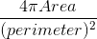   This means that a circle has a circularity of 1, circularity of a square is 0.785, and so on.

**3. Convexity:**

A picture is worth a thousand words.  Convexity is defined as the (Area of the Blob / Area of its convex hull). Now, Convex Hull of a shape is the tightest convex shape that completely encloses the shape.  To filter by convexity, set **filterByConvexity**= 1**,**followed by setting 0 ≤ **minConvexity**≤ 1and **maxConvexity**(≤ 1)

**4. Inertia Ratio:**

Don’t let this scare you. Mathematicians often use confusing words to describe something very simple. All you have to know is that this measures how elongated a shape is. E.g., for a circle, this value is 1, for an ellipse it is between 0 and 1, and for a line it is 0. To filter by inertia ratio, set **filterByInertia**= 1**,**and set 0 ≤ **minInertiaRatio**≤ 1and **maxInertiaRatio** (≤ 1) appropriately.

Output:

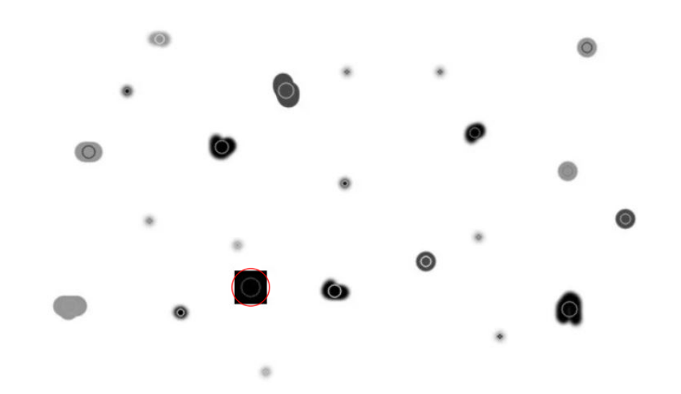

Edge detection using open cv:

Code:

import cv2

# Read the original image

img = cv2.imread('edge test.jpg')

# Display original image

cv2\_imshow(img)

cv2.waitKey(0)

# Convert to graycsale

img\_gray = cv2.cvtColor(img, cv2.COLOR\_BGR2GRAY)

# Blur the image for better edge detection

img\_blur = cv2.GaussianBlur(img\_gray, (3,3), 0)

# Sobel Edge Detection

sobelx = cv2.Sobel(src=img\_blur, ddepth=cv2.CV\_64F, dx=1, dy=0, ksize=5) # Sobel Edge Detection on the X axis

sobely = cv2.Sobel(src=img\_blur, ddepth=cv2.CV\_64F, dx=0, dy=1, ksize=5) # Sobel Edge Detection on the Y axis

sobelxy = cv2.Sobel(src=img\_blur, ddepth=cv2.CV\_64F, dx=1, dy=1, ksize=5) # Combined X and Y Sobel Edge Detection

# Display Sobel Edge Detection Images

cv2\_imshow(sobelx)

cv2.waitKey(0)

cv2\_imshow(sobely)

cv2.waitKey(0)

cv2\_imshow(sobelxy)

cv2.waitKey(0)

# Canny Edge Detection

edges = cv2.Canny(image=img\_blur, threshold1=100, threshold2=200) # Canny Edge Detection

# Display Canny Edge Detection Image

cv2\_imshow( edges)

cv2.waitKey(0)

cv2.destroyAllWindows()

exp:

Edge detection is an image-processing technique, which is used to identify the boundaries (edges) of objects, or regions within an image. Edges are among the most important features associated with images. We come to know of the underlying structure of an image through its edges. Computer vision processing pipelines therefore extensively use edge detection in applications.

Edges are characterized by sudden changes in pixel intensity. To detect edges, we need to go looking for such changes in the neighbouring pixels. Come, let’s explore the use of two important edge-detection algorithms available in OpenCV: Sobel Edge Detection and Canny Edge Detection. We will discuss the theory as well as demonstrate the use of each in OpenCV.

Sobel Edge Detection is one of the most widely used algorithms for edge detection. The Sobel Operator detects edges that are marked by sudden changes in pixel intensity, as shown in the figure below.

[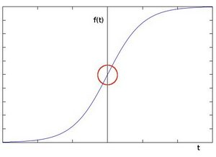](https://learnopencv.com/wp-content/uploads/2021/06/pixel_intensity.png)

Pixel intensity as a function of t ([Source](https://docs.opencv.org/3.4/d2/d2c/tutorial_sobel_derivatives.html))

The rise in intensity is even more evident, when we plot the first derivative of the intensity function.

[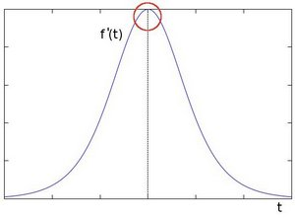](https://learnopencv.com/wp-content/uploads/2021/06/first_derivative.png)

First Derivative of Pixel intensity as a function of t ([Source](https://docs.opencv.org/3.4/d2/d2c/tutorial_sobel_derivatives.html))

The above plot demonstrates that edges can be detected in areas where the gradient is higher than a particular threshold value. In addition, a sudden change in the derivative will reveal a change in the pixel intensity as well. With this in mind, we can approximate the derivative, using a 3×3 kernel. We use one kernel to detect sudden changes in pixel intensity in the X direction, and another in the Y direction. (To learn more about image filtering and convolution kernels, [click here](https://learnopencv.com/image-filtering-using-convolution-in-opencv/)).

These are the kernels used for Sobel Edge Detection:

(1) 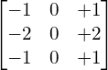

X-Direction Kernel

(2) 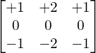

Y-Direction Kernel

When these kernels are convolved with the original image, you get a ‘Sobel edge image’.

* If we use only the Vertical Kernel, the convolution yields a Sobel image, with edges enhanced in the X-direction
* Using the Horizontal Kernel yields a Sobel image, with edges enhanced in the Y-direction.

Let  and  represent the intensity gradient in the  and  directions respectively. If  and  denote the X and Y kernels defined above:

(3) 

(4) 

where  denotes the convolution operator, and  represents the input image.

The final approximation of  the gradient magnitude,  can be computed as:

(5) 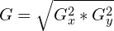

And the orientation of the gradient can then be approximated as:

(6) 

In the code example below, we use the **Sobel()** function to compute:

* the Sobel edge image individually, in both directions (x and y),
* the composite gradient in both directions (xy)

The following is the syntax for applying Sobel edge detection using OpenCV:

Sobel(src, ddepth, dx, dy)

The parameter **ddepth** specifies the precision of the output image, while **dx** and **dy** specify the order of the derivative in each direction. For example:

* If **dx=1** and **dy=0**, we compute the 1st derivative Sobel image in the x-direction.

 If both **dx=1** and **dy=1**, we compute the 1st derivative Sobel image in both directions.

**Canny Edge Detection**

Canny Edge Detection is one of the most popular edge-detection methods in use today because it is so robust and flexible.The algorithm itself follows a three-stage process for extracting edges from an image. Add to it image blurring, a necessary preprocessing step to reduce noise. This makes it a four-stage process, which includes:

1. Noise Reduction
2. Calculating Intensity Gradient of the Image
3. Suppression of False Edges
4. Hysteresis Thresholding

**Noise Reduction**

Raw image pixels can often lead to noisy edges, so it is important to reduce noise before computing edges In Canny Edge Detection, a Gaussian blur filter is used to essentially remove or minimize unnecessary detail that could lead to undesirable edges. Have a look at the tiger in the two images below, Gaussian blur has been applied to the image to the right. As you can see, it appears slightly blurred, but still retains a significant amount of detail from which edges can be computed.

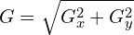

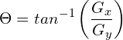

**Suppression of False Edges**

After reducing noise and calculating the intensity gradient, the algorithm in this step uses a technique called non-maximum suppression of edges to filter out unwanted pixels (which may not actually constitute an edge). To accomplish this, each pixel is compared to its neighboring pixels, in the positive and negative gradient direction. If the gradient magnitude of the current pixel is greater than its neighbouring pixels, it is left unchanged. Otherwise, the magnitude of the current pixel is set to zero. The following image illustrates an example.  As you can see, numerous ‘edges’ associated with the fur of the tiger have been significantly subdued.

**Hysteresis Thresholding**

In this final step of Canny Edge Detection, the gradient magnitudes are compared with two threshold values, one smaller than the other.

* If the gradient magnitude value is higher than the larger threshold value, those pixels are associated with strong edges, and are included in the final edge map.
* If the gradient magnitude values are lower than the smaller threshold value, the pixels are suppressed, and excluded from the final edge map.
* All the other pixels, whose gradient magnitudes fall in between these two thresholds, are marked as ‘weak’ edges (i.e. they become candidates for being included in the final edge map).
* If the ‘weak’ pixels are connected  to those associated with strong edges, then they too are included in the final edge map.

The following is the syntax for applying Canny edge detection using OpenCV:

Canny(image, threshold1, threshold2)

In the code example below, the  **Canny()** function implements the methodology described above. We just supply the two thresholds used by the Canny Edge Detection algorithm, and OpenCV handles all the implementation details. Don’t forget to blur the image, before calling the **Canny()** function. It is a highly-recommended pre-processing step.

Output:

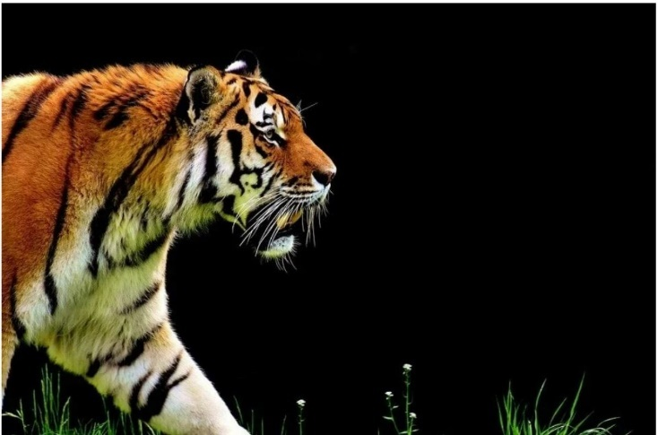

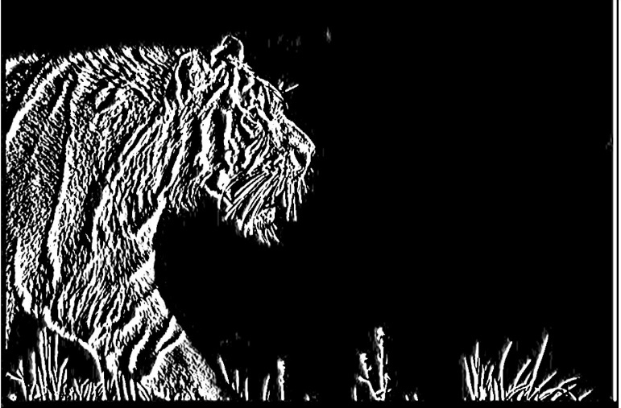

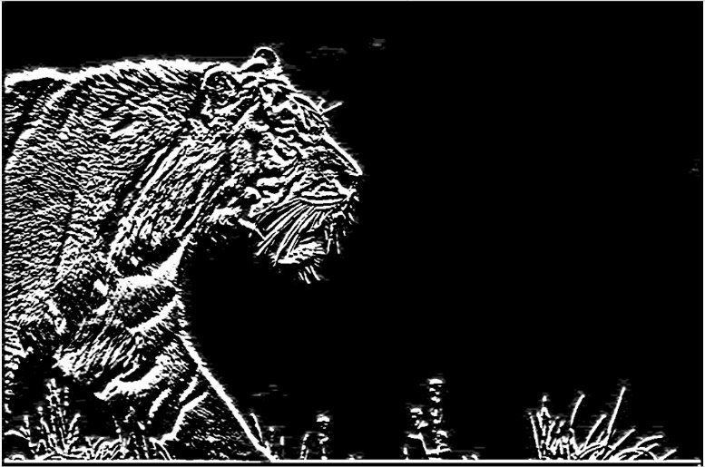

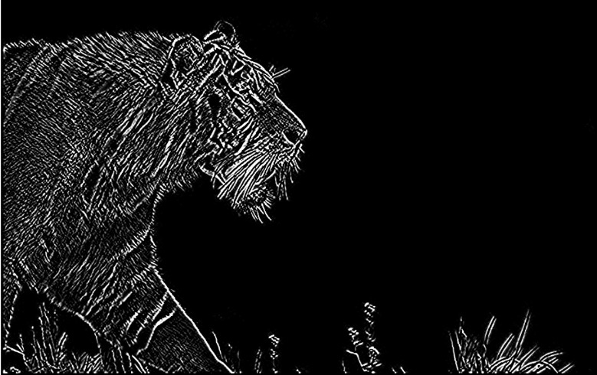

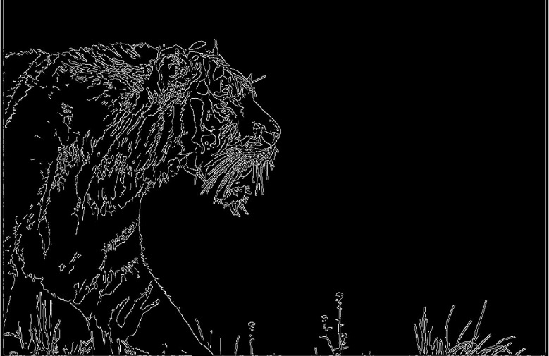

Annotating image using mouse in open cv: (this feature didn’t work in google colab so try for any other ide line pycharm to test it) just modify the cv2\_imshow() with cv2.imshow(“image name with format”, image)

Code:

import cv2

# Lists to store the bounding box coordinates

top\_left\_corner=[]

bottom\_right\_corner=[]

# function which will be called on mouse input

def drawRectangle(action, x, y, flags, \*userdata):

  # Referencing global variables

  global top\_left\_corner, bottom\_right\_corner

  # Mark the top left corner when left mouse button is pressed

  if action == cv2.EVENT\_LBUTTONDOWN:

    top\_left\_corner = [(x,y)]

    # When left mouse button is released, mark bottom right corner

  elif action == cv2.EVENT\_LBUTTONUP:

    bottom\_right\_corner = [(x,y)]

    # Draw the rectangle

    cv2.rectangle(image, top\_left\_corner[0], bottom\_right\_corner[0], (0,255,0),2, 8)

    cv2\_imshow(image)

# Read Images

image = cv2.imread("input image.jpg")

# Make a temporary image, will be useful to clear the drawing

temp = image.copy()

# Create a named window

cv2.namedWindow("Window")

# highgui function called when mouse events occur

cv2.setMouseCallback("Window", drawRectangle)

k=0

# Close the window when key q is pressed

while k!=113:

  # Display the image

  cv2\_imshow(image)

  k = cv2.waitKey(0)

  # If c is pressed, clear the window, using the dummy image

  if (k == 99):

    image= temp.copy()

    cv2\_imshow(image)

cv2.destroyAllWindows()

OpenCV provides a mouse event-detection feature to detect various mouse operations like left-click and right-click. In this first example, we will show you how to use the mouse to render a rectangle, on an image displayed in a named window.

Begin by defining a special ‘Callback’ function that will draw a rectangle on the image displayed in the named window. Called only when certain user interface events are detected, this type of functions came to be known as the ‘Callback’ functions. Here, this particular function is associated with mouse events, so we define it as a [MouseCallback](https://docs.opencv.org/4.5.2/d7/dfc/group__highgui.html" \l "gab7aed186e151d5222ef97192912127a4" \t "_blank)function. You can however name the function whatever you like. In this case, we have named it **drawRectangle()**. This works because we are going to register this function name to be associated with mouse events. You need not specify any input arguments to the function, these will be populated automatically when the user interacts with the mouse.

Let’s understand how to associate this function with specific mouse events. As shown below, we create the logic to draw a rectangle, based on certain mouse events. Whenever the user interacts with the mouse, while it is over the image being displayed: The mouse event type and event flags are recorded, along with the mouse x and y coordinates. These are then passed to the function for processing. **\*userdata** is an optional argument that can provide further inputs to the callback function (we will not require it in this example though). When actions **LEFTBUTTONDOWN** and **LEFTBUTTONUP** are triggered, we store the coordinates in the respective variables and use them to draw the rectangle.

After defining this mouse callback function, we proceed to perform the following:

* Read the sample image from disk, using **imread()**
* Save a copy of the image, using **copy()** or **clone()** for C++
* Create a named window

Call **setMouseCallback()** to register the mouse callback function that we defined above, and (**drawRectangle()**) for mouse events that occur in the named window.

The general syntax for the **setMouseCallback()** function is shown below, and also documented [here](https://docs.opencv.org/4.5.2/d7/dfc/group__highgui.html#ga89e7806b0a616f6f1d502bd8c183ad3e).

**Python:**

cv2.setMouseCallback(winname, onMouse, userdata)

**C++:**

void cv::setMouseCallback(const String & winname, MouseCallback onMouse, void \* userdata = 0);

**Arguments**

* **winname**: Name of the window
* **onMouse**: Callback function for mouse events
* **userdata**: Optional argument passed to the callback

In the final step, we need to create a display loop that allows the user to interact with the named window. Therefore, in the code below, we:

Create a while loop that continuously displays the image, until the user presses the ‘q’ key (ASCII code: 113) to quit the application script.

Provide the functionality within the loop for the user to clear all previous annotations. The user can reset the image in the named window to the copy that was made when we read in the original image. This is simply accomplished by checking for a keyboard entry of ‘c’ (ASCII code: 99).

When the user exits the loop, we destroy the window, using destroyAllWindows().

Output:

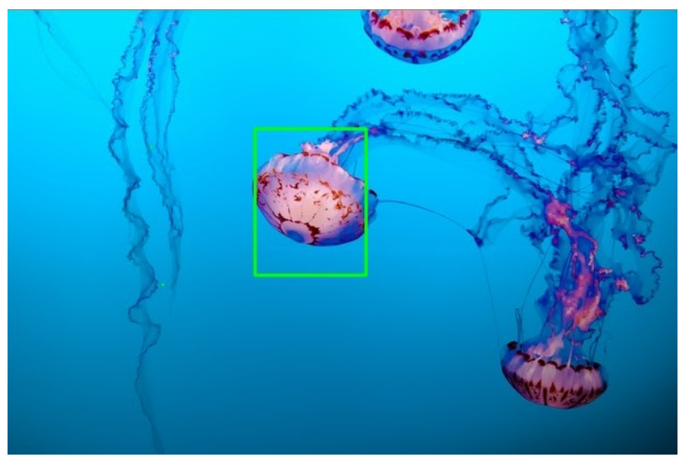

Resizing the image using track bar: (this code will not work on google colab just follow the procedure done for previous code)

Code:

# Import dependancies

import cv2

maxScaleUp = 100

scaleFactor = 1

windowName = "Resize Image"

trackbarValue = "Scale"

# read the image

image = cv2.imread("input image.jpg")

# Create a window to display results and  set the flag to Autosize

cv2.namedWindow(windowName, cv2.WINDOW\_AUTOSIZE)

# Callback functions

def scaleImage(\*args):

    # Get the scale factor from the trackbar

    scaleFactor = 1+ args[0]/100.0

    # Resize the image

    scaledImage = cv2.resize(image, None, fx=scaleFactor, fy = scaleFactor, interpolation = cv2.INTER\_LINEAR)

    cv2\_imshow(scaledImage)

# Create trackbar and associate a callback function

cv2.createTrackbar(trackbarValue, windowName, scaleFactor, maxScaleUp, scaleImage)

# Display the image

cv2\_imshow(image)

c = cv2.waitKey(0)

cv2.destroyAllWindows()

exp:

* **scaleFactor** will be used in the callback function that we are going to define for scaling the image.
* **maxScaleUp** is the maximum value that the trackbar position will record. It’s best to have 100 as the maximum value for we can then use the trackbar position to directly scale something as a percentage.

Read a sample image, using **imread()**, and also create a named window. In the **namedWindow()** function, we pass the **WINDOW\_AUTOSIZE** flag. This is important because it lets us resize the image.

We are now ready to talk about the callback function, it will be called when the user interacts with the trackbar. Defining a trackbar callback function is very similar to defining a mouse callback function. Simply conform to the [TrackbarCallback](https://docs.opencv.org/4.5.2/d7/dfc/group__highgui.html" \l "gaf78d2155d30b728fc413803745b67a9b" \t "_blank) function signature, then associate that callback function with the trackbar.

* Define the callback function, with the function signature, as shown below for Python and C++.
* As before, name the function whatever you like. In this case, we have named it **scaleImage()**.
* In the Python code, retrieve the trackbar position from **args[0]**, on a scale of 0 to 100.
* Compute a **scaleFactor,**  based on the trackbar position and input  that **scaleFactor** to the **resize()** function to resize the image.
* In the Python code, you need not specify any data type for the image. But in C++, you have to initialize it as a **Mat**.

To create a trackbar that uses our callback function, we need to call the **createTrackbar()** function, as documented [here](https://docs.opencv.org/4.5.2/d7/dfc/group__highgui.html#ga004b512c3d09aa53f20b050b1d01fab1). Check out its syntax in the code below.

**Python:**

cv2.createTrackbar( trackbarName, windowName, value, count, onChange)

**Arguments**

* **trackbarname**: Name of the created trackbar.
* **winname**: Name of the parent window of the created trackbar.
* **value**: Default position of the slider. This is optional.
* **count**: Till what value the slider will go.
* **onChange**: Callback function.
* **userdata**: User data that is passed to the callback function. It can be used to handle trackbar events, without using global variables.

Finally, we simply call imshow() to display the image in the named window. Followed by waitKey(0), with an argument of zero, which displays the window indefinitely.

Output:

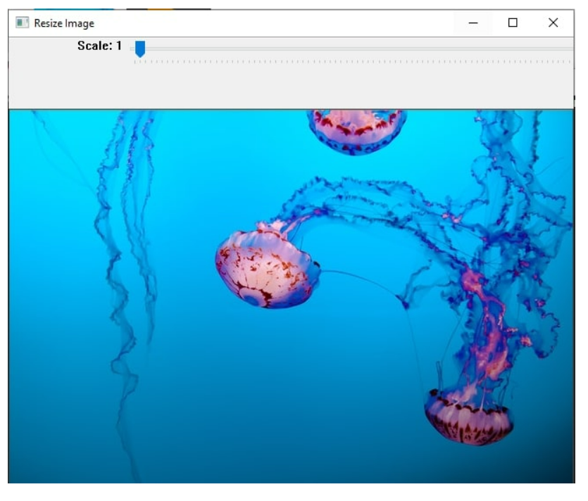

Edge detection of image using contour with chain approx. none in open cv:

Code:

import cv2

# read the image

image = cv2.imread('image\_1.jpg')

img\_gray = cv2.cvtColor(image, cv2.COLOR\_BGR2GRAY)

# apply binary thresholding

ret, thresh = cv2.threshold(img\_gray, 150, 255, cv2.THRESH\_BINARY)

# visualize the binary image

cv2\_imshow(thresh)

cv2.waitKey(0)

# cv2.imwrite('image\_thres1.jpg', thresh)

cv2.destroyAllWindows()

# detect the contours on the binary image using cv2.CHAIN\_APPROX\_NONE

contours, hierarchy = cv2.findContours(image=thresh, mode=cv2.RETR\_TREE, method=cv2.CHAIN\_APPROX\_NONE)

# draw contours on the original image

image\_copy = image.copy()

cv2.drawContours(image=image\_copy, contours=contours, contourIdx=-1, color=(0, 255, 0), thickness=2, lineType=cv2.LINE\_AA)

# see the results

cv2\_imshow(image\_copy)

cv2.waitKey(0)

#cv2.imwrite('contours\_none\_image1.jpg', image\_copy)

cv2.destroyAllWindows()

exp:

**What are Contours**

When we join all the points on the boundary of an object, we get a contour. Typically, a specific contour refers to boundary pixels that have the same color and intensity. OpenCV makes it really easy to find and draw contours in images. It provides two simple functions:

1. **findContours()**
2. **drawContours()**

Also, it has two different algorithms for contour detection:

1. **CHAIN\_APPROX\_SIMPLE**
2. **CHAIN\_APPROX\_NONE**

**Steps for Detecting and Drawing Contours in OpenCV**

OpenCV makes this a fairly simple task. Just follow these steps:

1. **Read the Image and convert it to Grayscale Format**

Read the image and convert the image to grayscale format. Converting the image to grayscale is very important as it prepares the image for the next step. Converting the image to a single channel grayscale image is important for thresholding, which in turn is necessary for the contour detection algorithm to work properly.

1. **Apply Binary Thresholding**

While finding contours, first always apply binary thresholding or Canny edge detection to the grayscale image. Here, we will apply binary thresholding.

This converts the image to black and white, highlighting the objects-of-interest to make things easy for the contour-detection algorithm. Thresholding turns the border of the object in the image completely white, with all pixels having the same intensity. The algorithm can now detect the borders of the objects from these white pixels.

**Note**: The black pixels, having value 0, are perceived as background pixels and ignored.

At this point, one question may arise. What if we use single channels like R (red), G (green), or B (blue) instead of grayscale (thresholded) images? In such a case, the contour detection algorithm will not work well. As we discussed previously, the algorithm looks for borders, and similar intensity pixels to detect the contours. A binary image provides this information much better than a single (RGB) color channel  image. In a later portion of the blog, we have resultant images when using only a single R, G, or B channel instead of grayscale and thresholded images.

1. **Find the Contours**

Use the **findContours()** function to detect the contours in the image.

1. **Draw Contours on the Original RGB Image.**

Once contours have been identified, use the **drawContours()** function to overlay the contours on the original RGB image.

**Drawing Contours using CHAIN\_APPROX\_NONE**

Start with the **findContours()**function. It has three required arguments, as shown below.

* **image**: The binary input image obtained in the previous step.
* **mode**: This is the contour-retrieval mode. We provided this as **RETR\_TREE,** which means the algorithm will retrieve all possible contours from the binary image. More contour retrieval modes are available, we will be discussing them too. You can learn more details on these options [here](https://docs.opencv.org/master/d3/dc0/group__imgproc__shape.html#ga819779b9857cc2f8601e6526a3a5bc71).
* **method**: This defines the contour-approximation method. In this example, we will use **CHAIN\_APPROX\_NONE**.Though slightly slower than **CHAIN\_APPROX\_SIMPLE**, we will use this method here tol store ALL contour points.

It’s worth emphasizing here that **mode** refers to the type of contours that will be retrieved, while **method** refers to which points within a contour are stored. We  will be discussing both in more detail  below.

It is easy to visualize and understand results from different methods on the same image.

In the code samples below, we therefore make a copy of the original image and then demonstrate the methods (not wanting to edit the original).

Next, use the **drawContours()** function to overlay the contours on the RGB image. This function has four required and several optional arguments. The first four arguments below are required. For the optional arguments, please refer to the documentation page [here](https://docs.opencv.org/master/d6/d6e/group__imgproc__draw.html#ga746c0625f1781f1ffc9056259103edbc).

* **image**: This is the input RGB image on which you want to draw the contour.
* **contours**: Indicates the **contours** obtained from the **findContours()** function.
* **contourIdx**: The pixel coordinates of the contour points are listed in the obtained contours. Using this argument, you can specify the index position from this list, indicating exactly which contour point you want to draw. Providing a negative value will draw all the contour points.
* **color**: This indicates the color of the contour points you want to draw. We are drawing the points in green.
* **thickness**: This is the thickness of contour points.

Output:

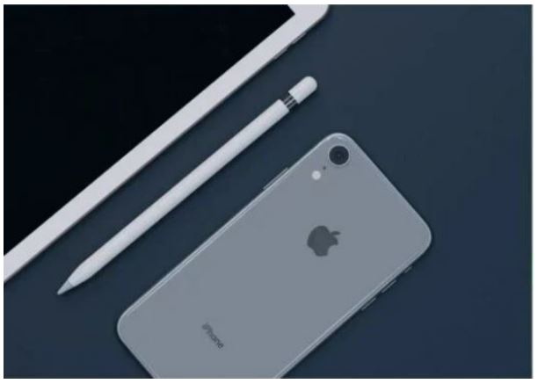

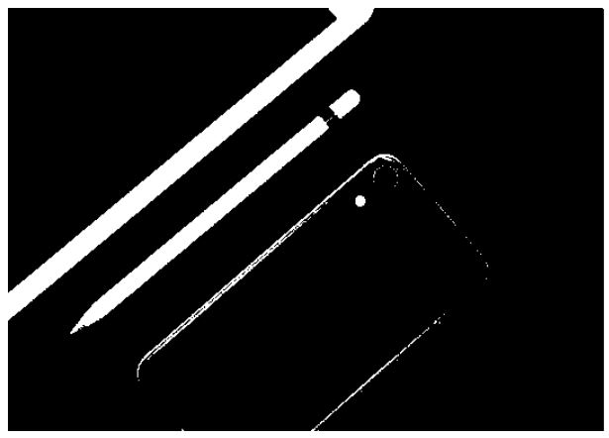

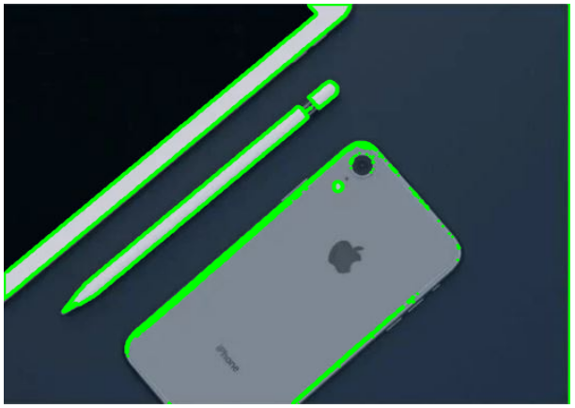

Finding contour without conversion of Gray scale using single colour channel : red, blue, green:

Code:

import cv2

# read the image

image = cv2.imread('image\_1.jpg')

# B, G, R channel splitting

blue, green, red = cv2.split(image)

# detect contours using blue channel and without thresholding

contours1, hierarchy1 = cv2.findContours(image=blue, mode=cv2.RETR\_TREE, method=cv2.CHAIN\_APPROX\_NONE)

# draw contours on the original image

image\_contour\_blue = image.copy()

cv2.drawContours(image=image\_contour\_blue, contours=contours1, contourIdx=-1, color=(0, 255, 0), thickness=2, lineType=cv2.LINE\_AA)

# see the results

cv2\_imshow(image\_contour\_blue)

print("\n")

cv2.waitKey(0)

#cv2.imwrite('blue\_channel.jpg', image\_contour\_blue)

cv2.destroyAllWindows()

# detect contours using green channel and without thresholding

contours2, hierarchy2 = cv2.findContours(image=green, mode=cv2.RETR\_TREE, method=cv2.CHAIN\_APPROX\_NONE)

# draw contours on the original image

image\_contour\_green = image.copy()

cv2.drawContours(image=image\_contour\_green, contours=contours2, contourIdx=-1, color=(0, 255, 0), thickness=2, lineType=cv2.LINE\_AA)

# see the results

cv2\_imshow(image\_contour\_green)

print("\n")

cv2.waitKey(0)

#cv2.imwrite('green\_channel.jpg', image\_contour\_green)

cv2.destroyAllWindows()

# detect contours using red channel and without thresholding

contours3, hierarchy3 = cv2.findContours(image=red, mode=cv2.RETR\_TREE, method=cv2.CHAIN\_APPROX\_NONE)

# draw contours on the original image

image\_contour\_red = image.copy()

cv2.drawContours(image=image\_contour\_red, contours=contours3, contourIdx=-1, color=(0, 255, 0), thickness=2, lineType=cv2.LINE\_AA)

# see the results

cv2\_imshow(image\_contour\_red)

cv2.waitKey(0)

#cv2.imwrite('red\_channel.jpg', image\_contour\_red)

cv2.destroyAllWindows()

exp:

Contour detection results when using blue, green and red single channels instead of grayscale, thresholded images.

In the below imageswe can see that the contour detection algorithm is not able to find the contours properly. This is because it is not able to detect the borders of the objects properly, and also the intensity difference between the pixels is not well defined. This is the reason we prefer to use a grayscale, and binary thresholded image for detecting contours.

Output:

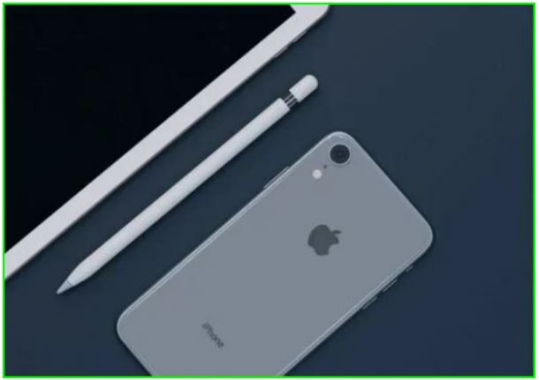

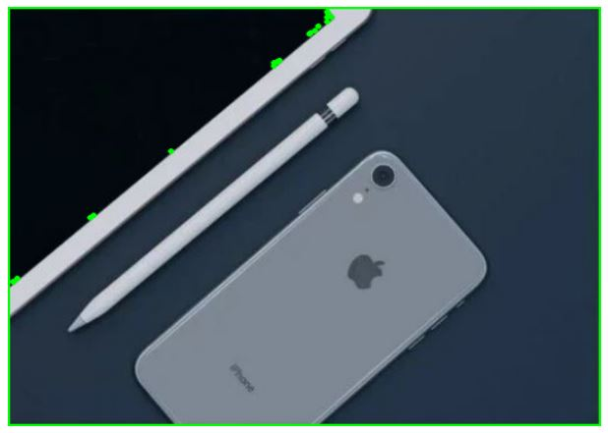

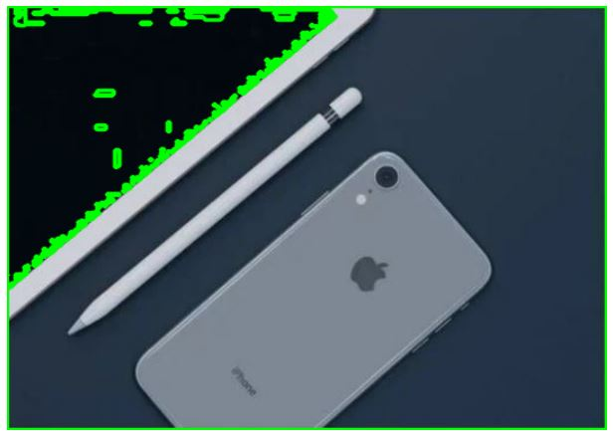

Drawing counters using chain approx. simple:

Code:

contours1, hierarchy1 = cv2.findContours(thresh, cv2.RETR\_TREE, cv2.CHAIN\_APPROX\_SIMPLE)

# draw contours on the original image for `CHAIN\_APPROX\_SIMPLE`

image\_copy1 = image.copy()

cv2.drawContours(image\_copy1, contours1, -1, (0, 255, 0), 2, cv2.LINE\_AA)

# see the results

cv2\_imshow(image\_copy1)

cv2.waitKey(0)

#cv2.imwrite('contours\_simple\_image1.jpg', image\_copy1)

cv2.destroyAllWindows()

exp:

The only difference here is that we specify the method for **findContours()**as **CHAIN\_APPROX\_SIMPLE** instead of **CHAIN\_APPROX\_NONE**.

The **CHAIN\_APPROX\_SIMPLE**  algorithm compresses horizontal, vertical, and diagonal segments along the contour and leaves only their end points. This means that any of the points along the straight paths will be dismissed, and we will be left with only the end points. For example, consider a contour, along a rectangle. All the contour points, except the four corner points will be dismissed. This method is faster than the **CHAIN\_APPROX\_NONE** because the algorithm does not store all the points, uses less memory, and therefore, takes less time to execute.

If you observe closely, there are almost no differences between the outputs of **CHAIN\_APPROX\_NONE**and **CHAIN\_APPROX\_SIMPLE**.

***Now, why is that?***

The credit goes to the **drawContours()** function. Although the **CHAIN\_APPROX\_SIMPLE**method typically results in fewer points, the **drawContours()** function automatically connects adjacent points, joining them even if they are not in the **contours**list.

So, how do we confirm that the **CHAIN\_APPROX\_SIMPLE** algorithm is actually working?

* The most straightforward way is to loop over the contour points manually, and draw a circle on the detected contour coordinates, using OpenCV.
* Also, we use a different image that will actually help us visualize the results of the algorithm.

Output:

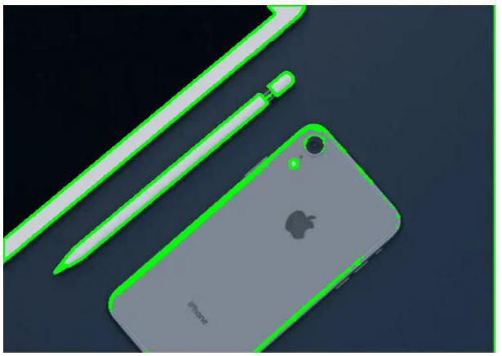

Explanation of chain approx. simple in detailed for loop:

Code:

# to actually visualize the effect of `CHAIN\_APPROX\_SIMPLE`, we need a proper image

image1 = cv2.imread('image\_2.jpg')

img\_gray1 = cv2.cvtColor(image1, cv2.COLOR\_BGR2GRAY)

ret, thresh1 = cv2.threshold(img\_gray1, 150, 255, cv2.THRESH\_BINARY)

contours2, hierarchy2 = cv2.findContours(thresh1, cv2.RETR\_TREE,

                                               cv2.CHAIN\_APPROX\_SIMPLE)

image\_copy2 = image1.copy()

cv2.drawContours(image\_copy2, contours2, -1, (0, 255, 0), 2, cv2.LINE\_AA)

cv2\_imshow(image\_copy2)

print("\n")

cv2.waitKey(0)

image\_copy3 = image1.copy()

for i, contour in enumerate(contours2): # loop over one contour area

   for j, contour\_point in enumerate(contour): # loop over the points

       # draw a circle on the current contour coordinate

       cv2.circle(image\_copy3, ((contour\_point[0][0], contour\_point[0][1])), 2, (0, 255, 0), 2, cv2.LINE\_AA)

# see the results

cv2\_imshow(image\_copy3)

cv2.waitKey(0)

#cv2.imwrite('contour\_point\_simple.jpg', image\_copy3)

cv2.destroyAllWindows()

exp:

The following code uses the above image to visualize the effect of the **CHAIN\_APPROX\_SIMPLE** algorithm. Almost everything is the same as in the previous code example, except the two additional **for** loops and some variable names.

* The first **for** loop cycles over each contour area present in the **contours** list.
* The second loops over each of the coordinates in that area.
* We then draw a green circle on each coordinate point, using the **circle()** function from OpenCV.
* Finally, we visualize the results and save it to disk.

Observe that there are only four contour dots on the four corners of the book when using CHAIN\_APPROX\_SIMPLE for contour detection. The vertical and horizontal straight lines of the book are completely ignored.

Observe the output image, which is on the second figure given below**.**Note that the vertical and horizontal sides of the book contain only four points at the corners of the book. Also observe that the letters and bird are indicated with discrete points and not line segments.

Output:

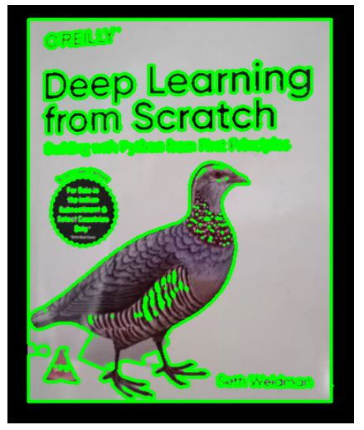

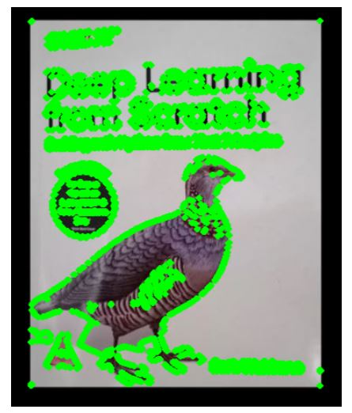

Contour hierarchies: retr list:

Code:

image2 = cv2.imread('image\_3.jpg')

img\_gray2 = cv2.cvtColor(image2, cv2.COLOR\_BGR2GRAY)

ret, thresh2 = cv2.threshold(img\_gray2, 150, 255, cv2.THRESH\_BINARY)

contours3, hierarchy3 = cv2.findContours(thresh2, cv2.RETR\_LIST, cv2.CHAIN\_APPROX\_NONE)

image\_copy4 = image2.copy()

cv2.drawContours(image\_copy4, contours3, -1, (0, 255, 0), 2, cv2.LINE\_AA)

# see the results

cv2\_imshow(image\_copy4)

print(f"LIST: {hierarchy3}")

cv2.waitKey(0)

#cv2.imwrite('contours\_retr\_list.jpg', image\_copy4)

cv2.destroyAllWindows()

exp:

Hierarchies denote the parent-child relationship between contours. You will see how each contour-retrieval mode affects contour detection in images, and produces hierarchical results.

**Parent-Child Relationship**

Objects detected by contour-detection algorithms in an image could be:

* Single objects scattered around in an image (as in the first example), or
* Objects and shapes inside one another

In most cases, where a shape contains more shapes, we can safely conclude that the outer shape is a parent of the inner shape.

Take a look at the following figure, it contains several simple shapes that will help demonstrate contour hierarchies.

[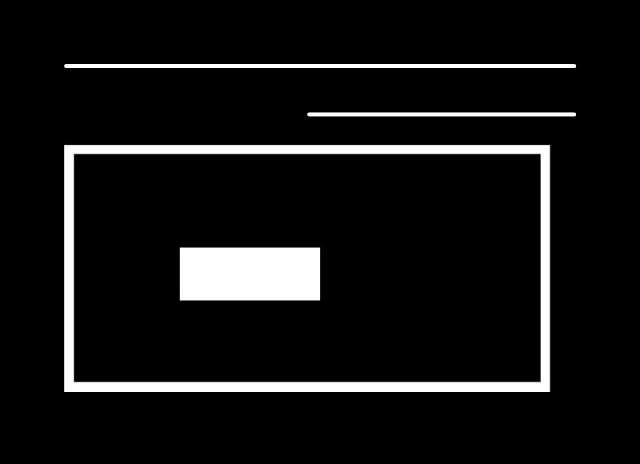](https://learnopencv.com/wp-content/uploads/2021/03/sample-image-with-straight-lines-and-simple-rectangular-shapes-to-visualize-and-discuss-contour-hierarchies.jpg)

Image with simple lines and shapes. We will use this image to learn more about contour hierarchies.

Now see below figure, where the contours associated with each shape in Figure 10 have been identified. Each of the numbers in Figure 11have a significance.

* All the individual numbers, i.e., 1, 2, 3, and 4 are separate objects, according to the contour hierarchy and parent-child relationship.
* We can say that the 3a is a child of 3. Note that 3a represents the interior portion of contour 3.
* Contours 1, 2, and 4 are all parent shapes, without any associated child, and their numbering is thus arbitrary. In other words, contour 2 could have been labeled as 1 and vice-versa.

[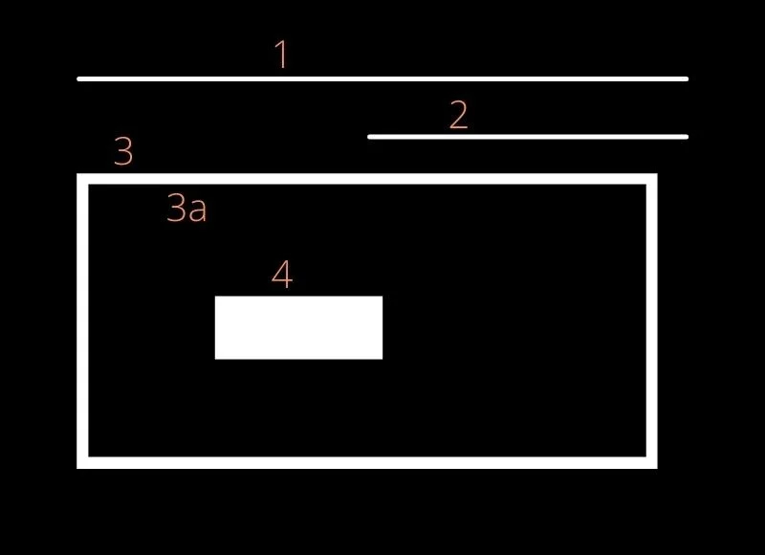](https://learnopencv.com/wp-content/uploads/2021/03/above-input-image-with-lines-and-shapes-numbered-to-show-the-parent-child-relationship.jpg)

Numbers showing the parent-child relationship between different shapes.

**Contour Relationship Representation**

You’ve seen that the **findContours()**function returns two outputs: The contours list, and the hierarchy. Let’s now understand the contour hierarchy output in detail.

The contour hierarchy is represented as an array, which in turn contains arrays of four values. It is represented as:

**[Next, Previous, First\_Child, Parent]**

So, what do all these values mean?

**Next:**Denotes the next contour in an image, which is at the same hierarchical level. So,

* For contour 1, the next contour at the same hierarchical level is 2. Here, **Next** will be 2.
* Accordingly, contour 3 has no contour at the same hierarchical level as itself. So, it’s **Next** value will be -1.

**Previous:**Denotes the previous contour at the same hierarchical level. This means that contour 1 will always have its **Previous** value as -1.

**First\_Child:**Denotes the first child contour of the contour we are currently considering.

* Contours 1 and 2 have no children at all. So, the index values for their **First\_Child**will be -1.
* But contour 3 has a child. So, for contour 3, the **First\_Child**position value will be the index position of 3a.

**Parent:** Denotes the parent contour’s index position for the current contour.

* Contours 1 and 2, as is obvious, do not have any **Parent** contour.
* For the contour 3a, its **Parent** is going to be contour 3
* For contour 4, the parent is contour 3a

The above explanations make sense, but how do we actually visualize these hierarchy arrays? The best way is to:

* Use a simple image with lines and shapes like the previous image
* Detect the contours and hierarchies, using different retrieval modes
* Then print the values to visualize them

The **RETR\_LIST** contour retrieval method does not create any parent child relationship between the extracted contours. So, for all the contour areas that are detected, the **First\_Child**and **Parent** index position values are always -1.

All the contours will have their corresponding **Previous** and **Next** contours as discussed above.

Output:

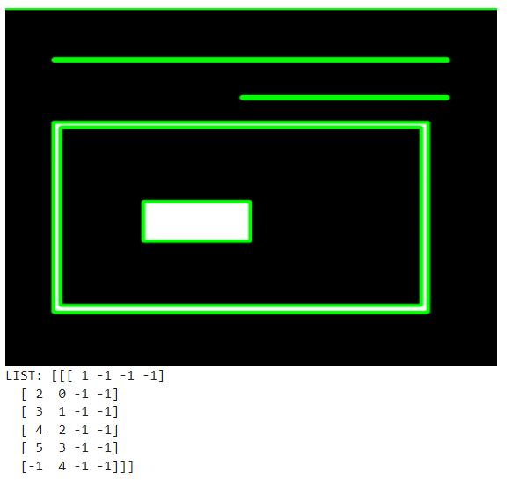

Using RETR\_EXTERNAL:

Code:

contours4, hierarchy4 = cv2.findContours(thresh2, cv2.RETR\_EXTERNAL, cv2.CHAIN\_APPROX\_NONE)

image\_copy5 = image2.copy()

cv2.drawContours(image\_copy5, contours4, -1, (0, 255, 0), 2, cv2.LINE\_AA)

# see the results

cv2\_imshow(image\_copy5)

print(f"EXTERNAL: {hierarchy4}")

cv2.waitKey(0)

#cv2.imwrite('contours\_retr\_external.jpg', image\_copy5)

cv2.destroyAllWindows()

exp:

The **RETR\_EXTERNAL** contour retrieval method is a really interesting one. It only detects the parent contours, and ignores any child contours. So, all the inner contours like 3a and 4 will not have any points drawn on them.

The below output image shows only the points drawn on contours 1, 2, and 3. Contours 3a and 4 are omitted as they are child contours.

Output:

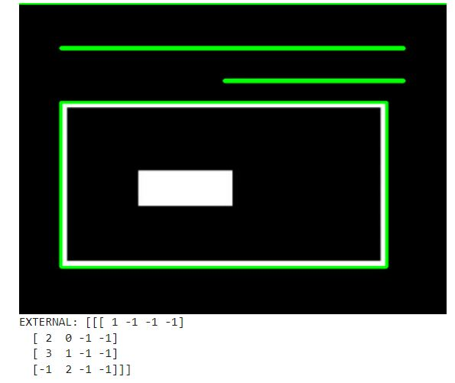

Using RETR\_CCOMP:

Code:

contours5, hierarchy5 = cv2.findContours(thresh2, cv2.RETR\_CCOMP, cv2.CHAIN\_APPROX\_NONE)

image\_copy6 = image2.copy()

cv2.drawContours(image\_copy6, contours5, -1, (0, 255, 0), 2, cv2.LINE\_AA)

# see the results

cv2\_imshow(image\_copy6)

print(f"CCOMP: {hierarchy5}")

cv2.waitKey(0)

#cv2.imwrite('contours\_retr\_ccomp.jpg', image\_copy6)

cv2.destroyAllWindows()

exp:

Unlike **RETR\_EXTERNAL**,**RETR\_CCOMP** retrieves all the contours in an image. Along with that, it also applies a 2-level hierarchy to all the shapes or objects in the image.

This means:

* All the outer contours will have hierarchy level 1
* All the inner contours will have hierarchy level 2

***But what if we have a contour inside another contour with hierarchy level 2? Just like we have contour 4 after contour 3a.***

In that case:

* Again, contour 4 will have hierarchy level 1.
* If there are any contours inside contour 4, they will have hierarchy level 2.

In the following image, the contours have been numbered according to their hierarchy level, as explained above.

[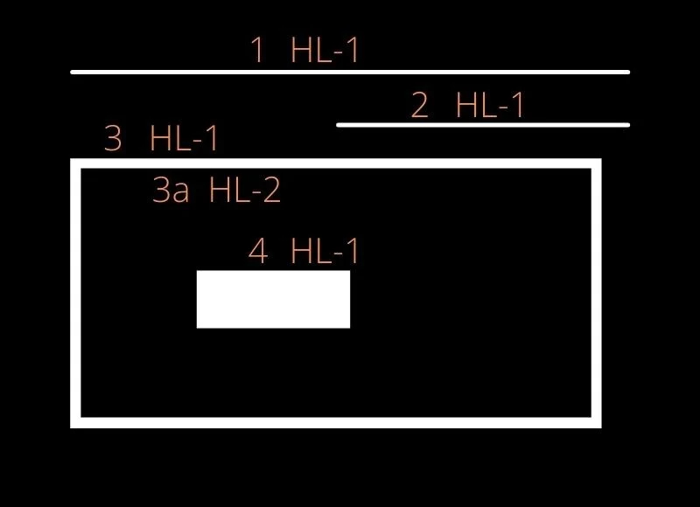](https://learnopencv.com/wp-content/uploads/2021/03/RETR-CCOMP-retrieval-method-hierarchy-levels-of-contours-numbered-for-visualization.jpg)

Image showing different hierarchy levels in contours when using RETR\_CCOMP retrieval method.

The above image shows the hierarchy level as **HL-1 or HL-2**for levels 1 and 2 respectively. Now, let us take a look at the code and the output hierarchy array also.

Output:

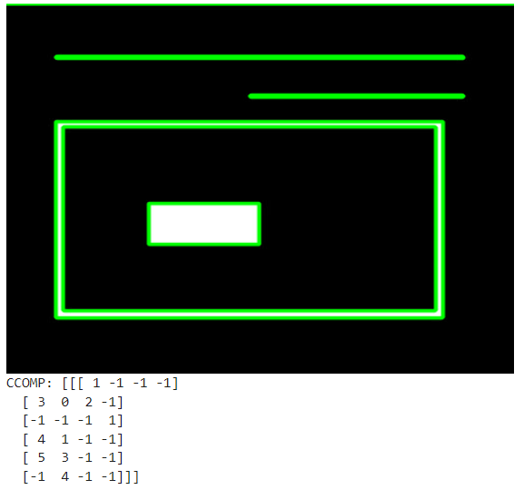

Here, we see that all the **Next**, **Previous**, **First\_Child**, and **Parent** relationships are maintained, according to the contour-retrieval method, as all the contours are detected. As expected, the **Previous** of the first contour area is -1. And the contours which do not have any **Parent,** also have the value -1

Using RETR\_TREE:

Code:

contours6, hierarchy6 = cv2.findContours(thresh2, cv2.RETR\_TREE, cv2.CHAIN\_APPROX\_NONE)

image\_copy7 = image2.copy()

cv2.drawContours(image\_copy7, contours6, -1, (0, 255, 0), 2, cv2.LINE\_AA)

# see the results

cv2\_imshow(image\_copy7)

print(f"TREE: {hierarchy6}")

cv2.waitKey(0)

#cv2.imwrite('contours\_retr\_tree.jpg', image\_copy7)

cv2.destroyAllWindows()

exp:

Just like **RETR\_CCOMP**, **RETR\_TREE** also retrieves all the contours. It also creates a complete hierarchy, with the levels not restricted to 1 or 2. Each contour can have its own hierarchy, in line with the level it is on, and the corresponding parent-child relationship that it has.

[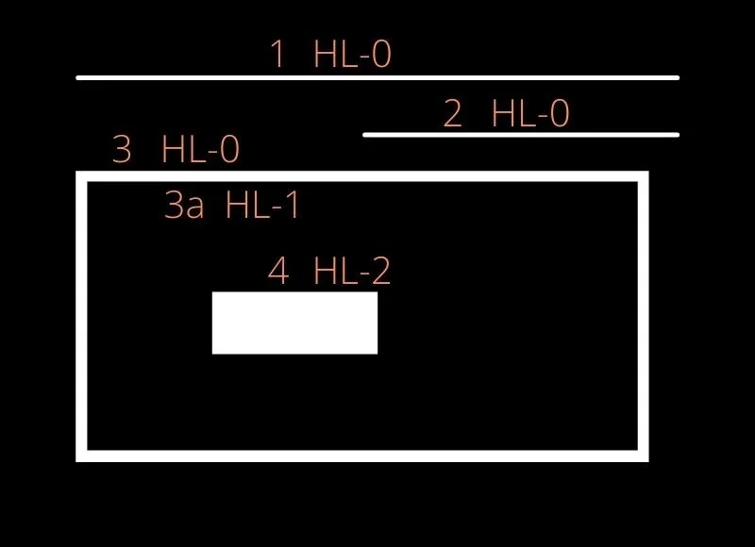](https://learnopencv.com/wp-content/uploads/2021/03/RETR-TREE-retrieval-method-hierarchy-levels-of-contours-numbered-for-visualization.jpg)

Hierarchy levels when using RETR\_TREE contour retrieval mode.

From the above figure, it is clear that:

* Contours 1, 2, and 3 are at the same level, that is level 0.
* Contour 3a is present at hierarchy level 1, as it is a child of contour 3.
* Contour 4 is a new contour area, so its hierarchy level is 2.
* Executing the above code produces the following output:
* TREE: [[[ 3 -1  1 -1]  
  [-1 -1  2  0]  
  [-1 -1 -1  1]  
  [ 4  0 -1 -1]  
  [-1  3 -1 -1]]]

Finally, let’s look at the complete image with all the contours drawn when using **RETR\_TREE** mode.

[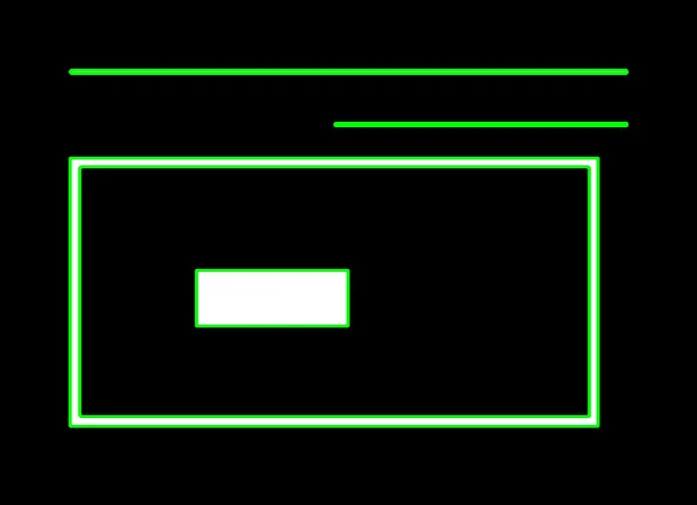](https://learnopencv.com/wp-content/uploads/2021/03/RETR-TREE-retrieval-mode-contours-detected-overlaid-on-input-image.jpg)

* Contour detection when using RETR\_TREE retrieval mode.
* All the contours are drawn as expected, and the contour areas are clearly visible. You also infer that contours 3 and 3a are two separate contours, as they have different contour boundaries and areas. At the same time, it is very evident that contour 3a is a child of contour 3.
* Now that you are familiar with all the contour algorithms available in OpenCV, along with their respective input parameters and configurations, go experiment and see for yourself how they work.

Output:

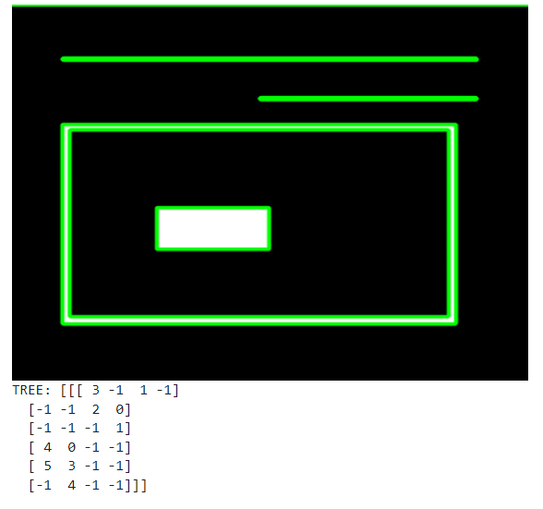

**A Run Time Comparison of Different Contour Retrieval Methods**

It’s not enough to know the contour-retrieval methods. You should also be aware of their relative processing time. The following table compares the runtime for each method discussed above.

|  |  |
| --- | --- |
| **Contour Retrieval Method** | **Time Take (in seconds)** |
| RETR\_LIST | 0.000382 |
| RETR\_EXTERNAL | 0.000554 |
| RETR\_CCOMP | 0.001845 |
| RETR\_TREE | 0.005594 |

Comparing the inference speed of different methods

Some interesting conclusions emerge from the above table:

* **RETR\_LIST** and **RETR\_EXTERNAL** take the least amount of time to execute, since **RETR\_LIST** does not define any hierarchy and **RETR\_EXTERNAL** only retrieves the parent contours
* **RETR\_CCOMP** takes the second highest time to execute. It retrieves all the contours and defines a two-level hierarchy.
* **RETR\_TREE** takes the maximum time to execute for it retrieves all the contours, and defines the independent hierarchy level for each parent-child relationship as well.

Although the above times may not seem significant, it is important to be aware of the differences for applications that may require a significant amount of contour processing. It is also worth noting that this processing time may vary, depending to an extent on the contours they extract, and the hierarchy levels they define.

**Limitations**

So far, all the examples we explored seemed interesting, and their results encouraging. However, there are cases where the contour algorithm might fail to deliver meaningful and useful results. Let’s consider such an example too.

* When the objects in an image are strongly contrasted against their background, you can clearly identify the contours associated with each object. But what if you have an image, like Figure 16 below. It not only has a bright object (puppy), but also a background cluttered with   the same value (brightness) as the object of interest (puppy). You find that the contours in the right-hand image are not even complete.  Also, there are multiple unwanted contours standing out in the background area.

[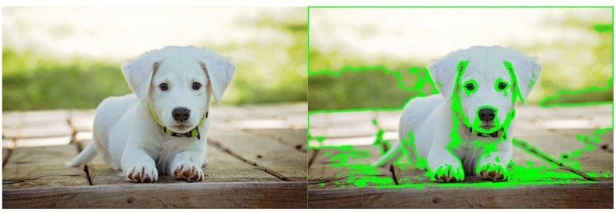](https://learnopencv.com/wp-content/uploads/2021/03/comparative-image-showing-a-failure-case-detection-of-multiple-or-incorrect-contours-due-to-clutter-in-the-background.jpg)

Left – input image with a white puppy and a lot of other edges and background colors. Right – the contour detection results overlaid. Observe how the contours are not complete, and the detection of multiple or incorrect contours due to clutter in the background.

* Contour detection can also fail, when the background of the object in the image is full of lines.

Simple Background Estimation in Videos using OpenCV

Code:

import numpy as np

import cv2

from skimage import data, filters

# Open Video

cap = cv2.VideoCapture('video.mp4')

# Randomly select 25 frames

frameIds = cap.get(cv2.CAP\_PROP\_FRAME\_COUNT) \* np.random.uniform(size=25)

# Store selected frames in an array

frames = []

for fid in frameIds:

    cap.set(cv2.CAP\_PROP\_POS\_FRAMES, fid)

    ret, frame = cap.read()

    frames.append(frame)

# Calculate the median along the time axis

medianFrame = np.median(frames, axis=0).astype(dtype=np.uint8)

# Display median frame

cv2\_imshow(medianFrame)

cv2.waitKey(0)

exp:

 technique for estimating the background of a scene when the camera is static and there are some moving objects in the scene. This scenario is not uncommon. For example, many traffic and surveillance cameras are rigidly fixed.

**Temporal Median Filtering**

To understand the idea we are going to describe in this post, let us consider a simpler problem in 1D.

Suppose we are estimating a quantity (say the temperature of the room) every 10 milliseconds.

Let’s say, the temperature of the room is 70 degrees Fahrenheit.

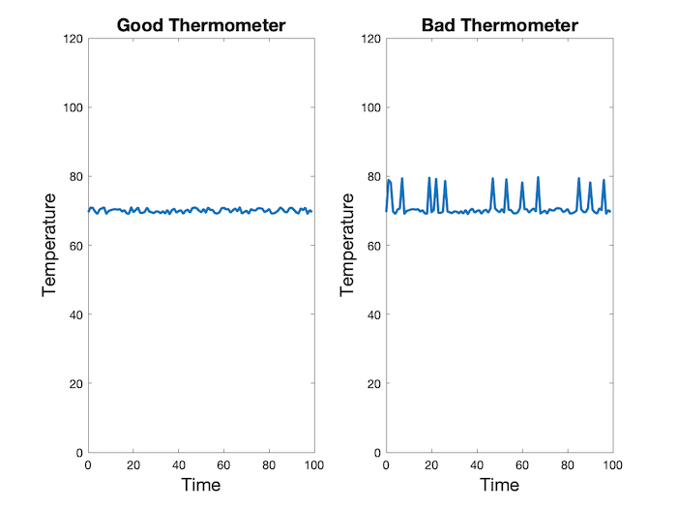

In the above figure, we have shown measurements from two thermometers — a good thermometer and a bad thermometer.

The good thermometer shown on the left reports 70 degrees with some level of Gaussian noise. To get a more accurate estimate of temperature, we can simply average the values over a few seconds. Since the noise is Gaussian with positive and negative values, the average will cancel out the noise. Indeed, the average value in this specific case is 70.01.

The bad thermometer, on the other hand, behaves like the good thermometer most of the time but occasionally, the numbers are completely wrong.

In fact, if we take an average of the numbers reported by the bad thermometer we get 71.07 degrees. This is clearly an overestimate.

Can we still get a good estimate of temperature?

The answer is YES. When the data contains outliers, the **median** is a more robust estimate of the value we are trying to estimate.

The median is the mid-value of the data when it is sorted in ascending or descending order.

The median of the curve shown above is 70.05 degrees which is a much better estimate than 71.07 degrees.

The only downside is that the median is more expensive to calculate compared to the mean/average.

**Using the Median for Background Estimation**

Now, let’s return to the problem of estimating the background when the camera is static.

We can assume most of the time, every pixel sees the same piece of the background because the camera is not moving. Occasionally, a car or other moving object comes in the front and obscure the background.

For a video sequence, we can randomly sample a few frames (say 25 frames).

In other words, for every pixel, we now have 25 estimates of the background. As long as a pixel is not covered by a car or other moving object more than 50% of the time, the median of the pixel over these 25 frames will give a good estimate of the background at that pixel.

We can repeat this for every pixel and recover the entire background.

Output:

As you can see, we randomly select 25 frames and calculate the median of every pixel over the 25 frames. This median frame is a good estimate of the background as long as every pixel sees the background at least 50% of the time.

The result is shown below

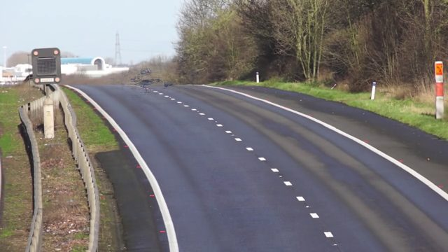

The estimate of the background is the **median frame** calculated by finding the median value of every pixel over 25 frames.

Video link: https://youtu.be/UTd40wOXUmY

Frame differencing

Code:

# Reset frame number to 0

cap.set(cv2.CAP\_PROP\_POS\_FRAMES, 0)

# Convert background to grayscale

grayMedianFrame = cv2.cvtColor(medianFrame, cv2.COLOR\_BGR2GRAY)

# Loop over all frames

ret = True

while(ret):

  # Read frame

  ret, frame = cap.read()

  # Convert current frame to grayscale

  frame = cv2.cvtColor(frame, cv2.COLOR\_BGR2GRAY)

  # Calculate absolute difference of current frame and

  # the median frame

  dframe = cv2.absdiff(frame, grayMedianFrame)

  # Treshold to binarize

  th, dframe = cv2.threshold(dframe, 30, 255, cv2.THRESH\_BINARY)

  # Display image

  cv2\_imshow(dframe)

  cv2.waitKey(20)

# Release video object

cap.release()

# Destroy all windows

cv2.destroyAllWindows()

exp:

**Frame differencing (C++ / Python)**

The obvious next question is if we can create a mask for every frame which shows parts of the image that are in motion.

This is accomplished in the following steps

1. Convert the median frame to grayscale.
2. Loop over all frames in the video. Extract the current frame and convert it to grayscale.
3. Calcualte the absolute difference between the current frame and the median frame.
4. Threshold the above image to remove noise and binarize the output.

Output:

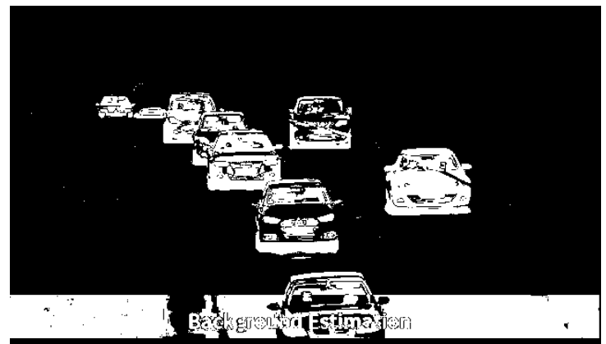

And all other similar frames.